* 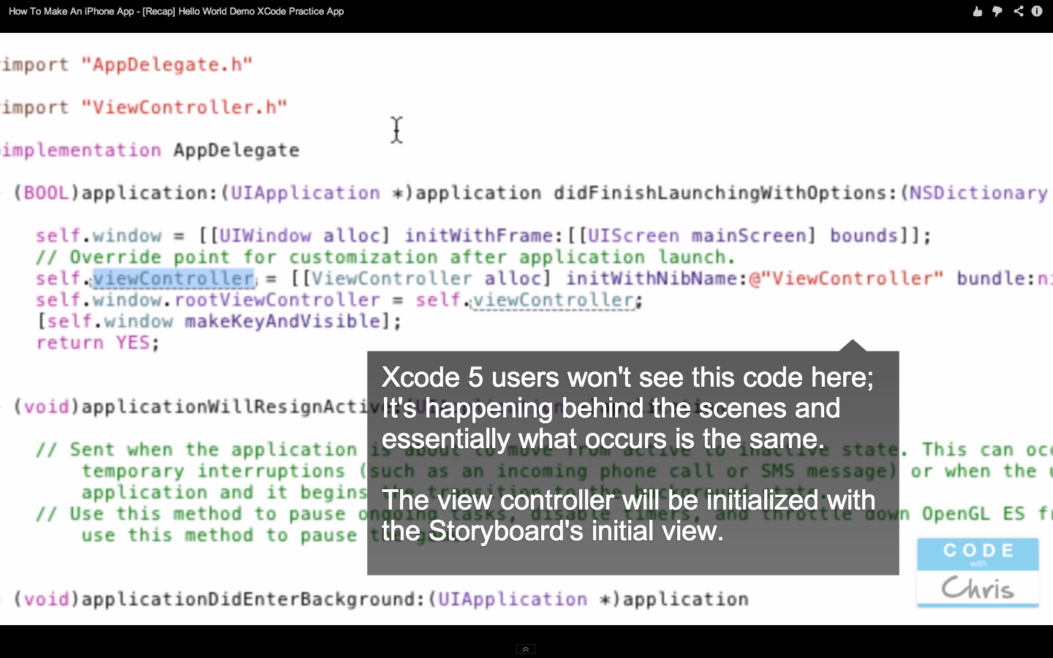

Note:

1. AppDelegate is an Object.
2. viewController (notice lowercase v) is a property of the Object AppDelegate which references the ViewController that was created
3. self.viewController refers to ViewController property of “this” instance of the AppDelegate Object (it exists within the AppDelegate implementation file)

* 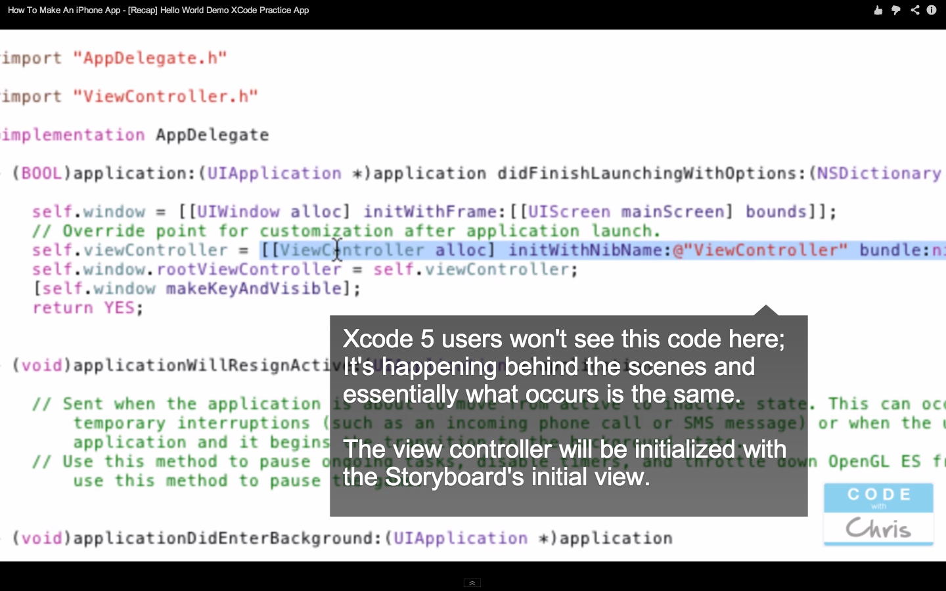

Another ViewController is being created

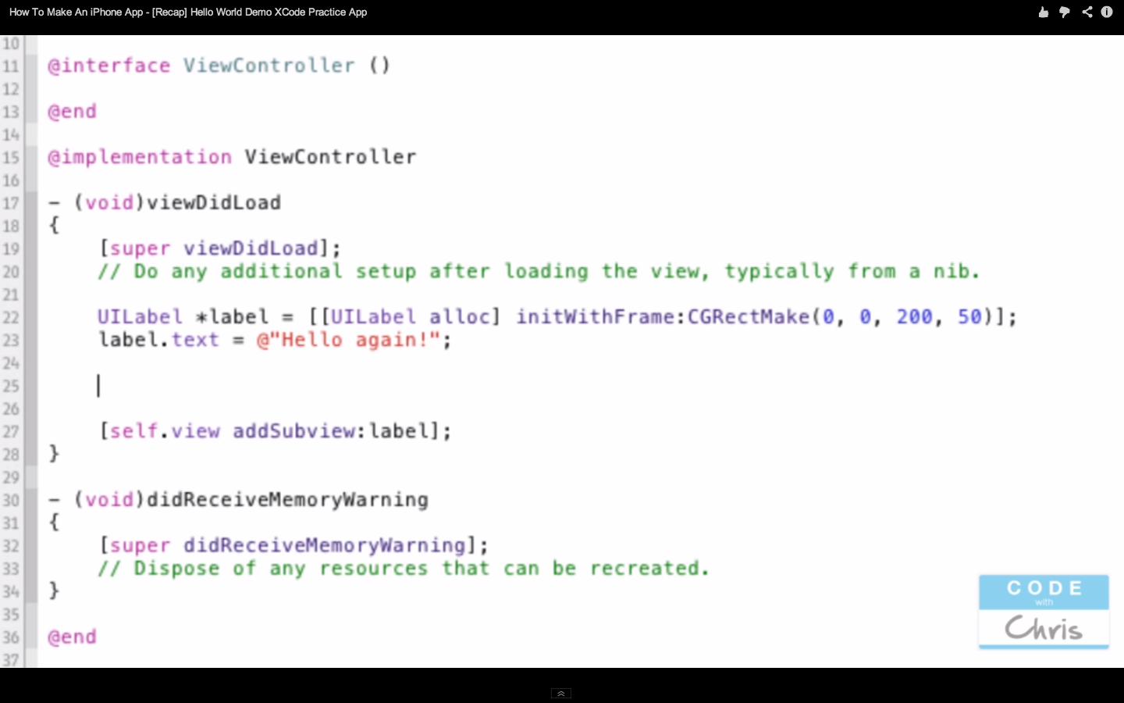

[UILabel alloc] creates a new UILabel Object and calls the method alloc to create space for it.

This would create the UILabel and return an Object

[ ] is how you call methods

In general you would create a Class using alloc and then call its initialization method.

See below: This is where the ViewController is created in AppDelegate and the property viewController refers to it. It is initialized with a special initialization method “initWithNibName”. (Note: Class definitions begin with a capitalized letter. properties and variables are lower case.

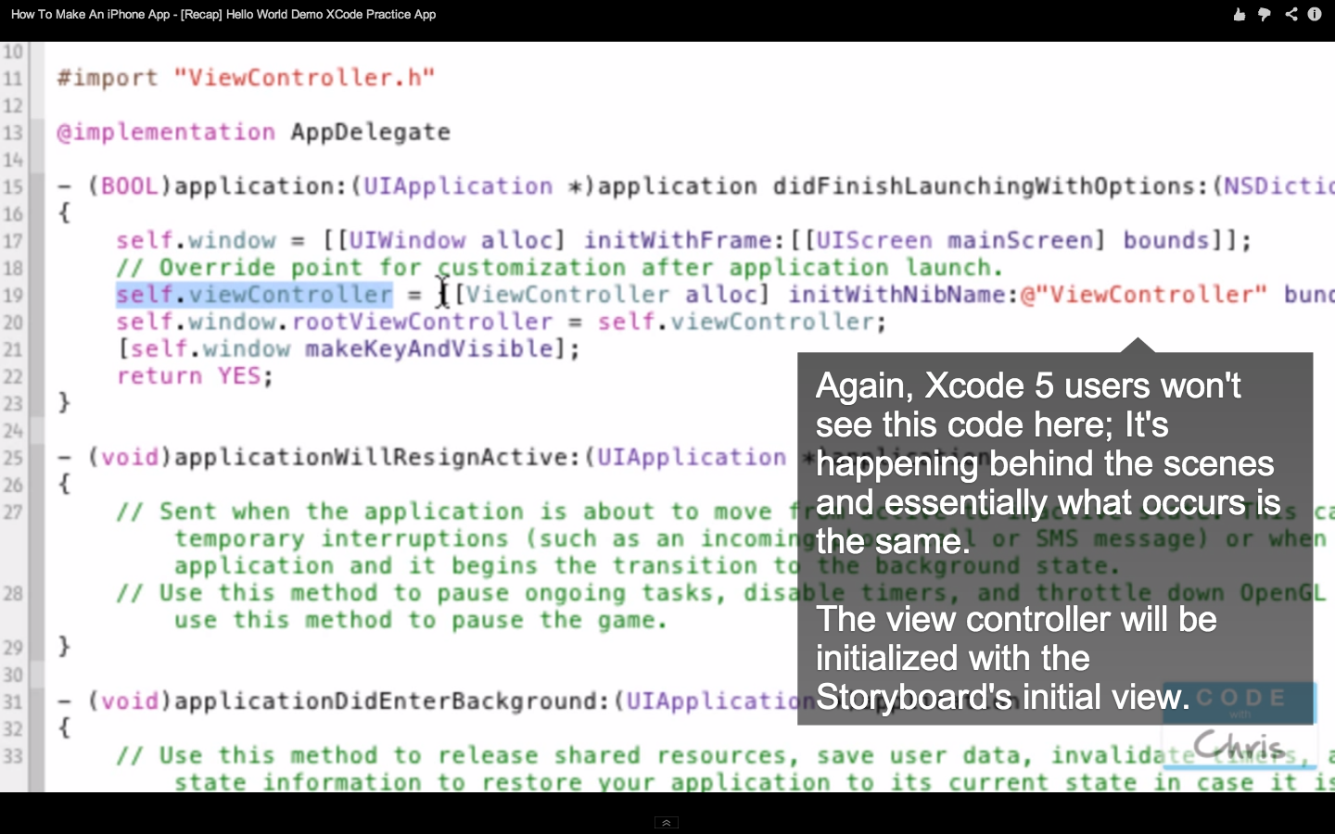

Need to create a variable to refer to the UILabel that is created so create it using: UILabel *label

This permits the Object’s properties to be referenced as in the “label.text”

**XCode Graphic Shortcuts:**

control drag from View into .h file creates a property to reference the Object (i.e. a UILabel, UITextBox, UIButton, etc)

control drag from the view into .m creates a method for the Object

**Ranajit** September 5, 2013, 3:27 pm

Want to know more on the method you have written, please slow down and explain, i am a newbie.

- (void)touchesBegan:(NSSet *)touches withEvent:(UIEvent *)event {  
[self.customTextField resignFirstResponder];  
}

[REPLY](http://codewithchris.com/xcode-tutorial-user-interaction/?replytocom=2836#commentform)

* **Chris Ching** September 7, 2013, 7:17 pm

Hello ranajit,

The touchesBegan method is a way to handle user touches on the screen. You can read a bit more about it here: (<http://bit.ly/1awzeqU>)

But essentially when the user touches the screen, that method is triggered and the code in there:  
“[self.customTextField resignFirstResponder];” makes the on-screen keyboard go away, otherwise when you tap out of the text field, the keyboard won’t disappear.

“self.customTextField” is referring to the textfield and “resignFirstResponder” is a method of the textfield that minimizes the on-screen keyboard.

* 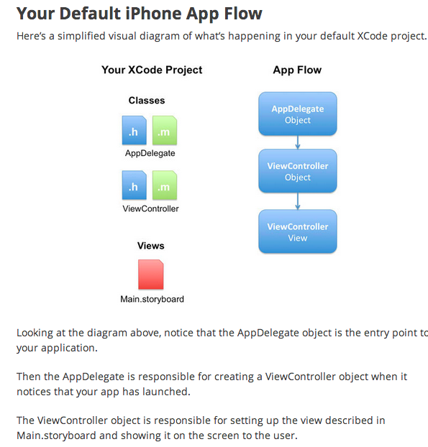

Main.storyboard is XML that is interpreted and creates a View Object (which is “View above)

* 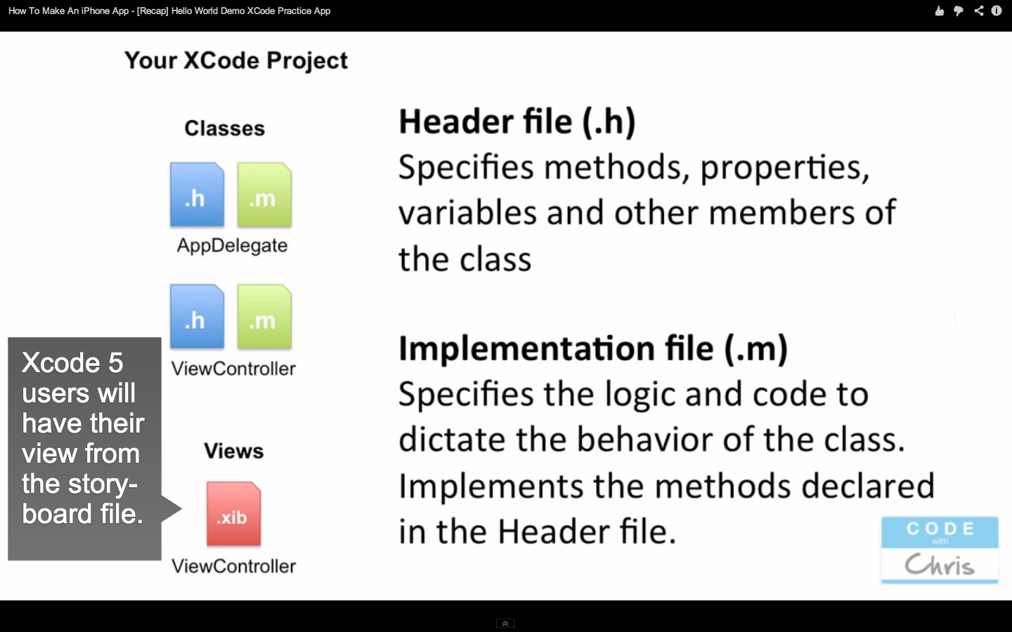
* 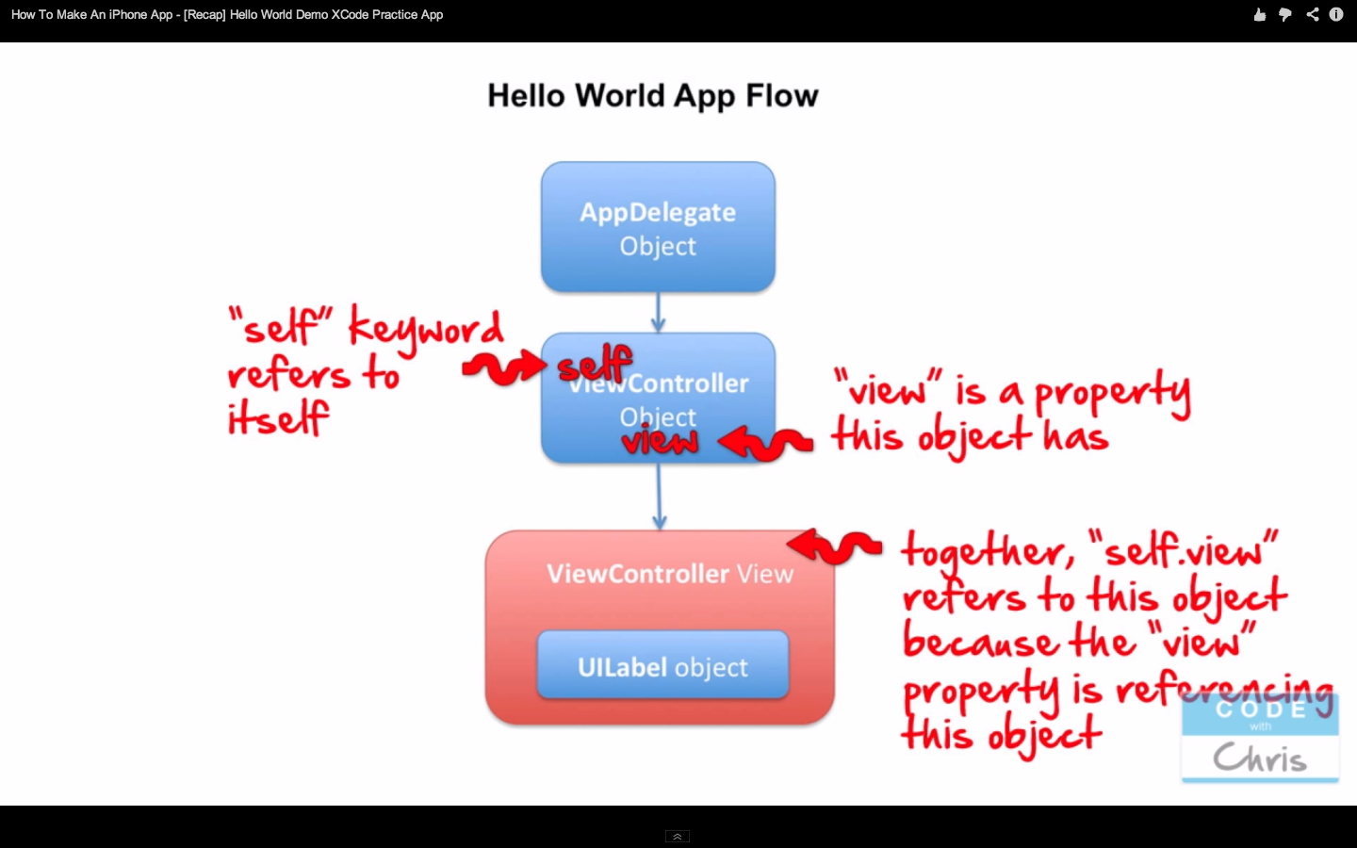
* 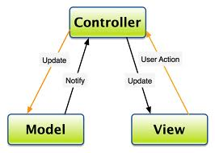
* Model NEVER communicates directly with the View??­­
* 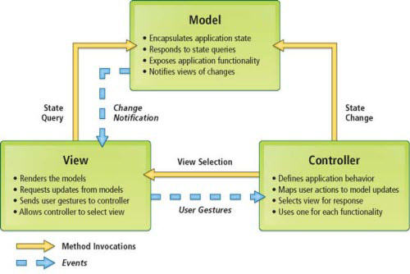
* Interface Builder
* Connections to Objects:
* Outlets
* An outlet is a property of an object that references another object. The reference is archived through Interface Builder. The connections between the containing object and its outlets are reestablished every time the containing object is unarchived from its nib file. The containing object holds an outlet declared as a property with the type qualifier of IBOutlet and a weak option. For example:

|  |
| --- |
| * @interface AppController : NSObject |
| * { |
| * } |
| * @property (weak) IBOutlet NSArray *keywords; |

* Because it is a property, an outlet becomes part of an object’s encapsulated data and is backed by an instance variable. But an outlet is more than a simple property. The connection between an object and its outlets is archived in a nib file; when the nib file is loaded, each connection is unarchived and reestablished, and is thus always available whenever it becomes necessary to send messages to the other object. The type qualifier IBOutlet is a tag applied to an property declaration so that the Interface Builder application can recognize the property as an outlet and synchronize the display and connection of it with Xcode.
* An outlet is declared as a weak reference (weak) to prevent strong reference cycles.
* You [create and connect an outlet](https://developer.apple.com/library/ios/recipes/xcode_help-interface_builder/articles-connections_bindings/CreatingOutlet.html#//apple_ref/doc/uid/TP40009971-CH15) in the Interface Builder feature of Xcode.The property declaration for the outlet must be tagged with the IBOutlet qualifier.
* An application typically sets outlet connections between its custom controller objects and objects on the user interface, but they can be made between any objects that can be represented as instances in Interface Builder, even between two custom objects. As with any item of object state, you should be able to justify its inclusion in a class; the more outlets an object has, the more memory it takes up. If there are other ways to obtain a reference to an object, such as finding it through its index position in a matrix, or through its inclusion as a function parameter, or through use of a tag (an assigned numeric identifier), you should do that instead.
* Outlets are a form of object composition, which is a dynamic pattern that requires an object to somehow acquire references to its constituent objects so that it can send messages to them. It typically holds these other objects as properties backed by instance variables. These variables must be initialized with the appropriate references at some point during the execution of the program.
* 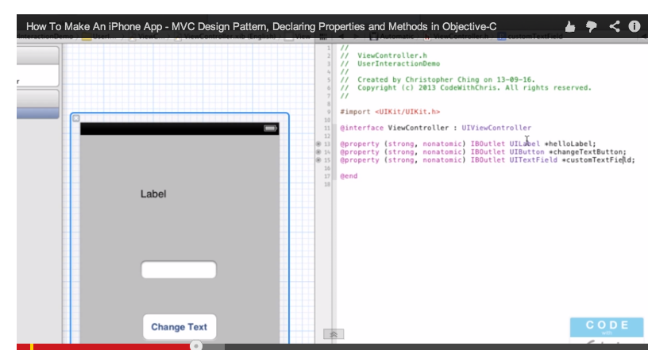
* Here helloLabel is a reference to the UILabel and is an IBOutlet of View Controller (declared in view controller.h) This permits methods in ViewController.m to reference the UILabel and send messages to it.
* EXAMPLE: textEntryLabel below is an IBOutlet property of ViewController which reference the UILabel element created in IB. It is declared below in ViewController.h and used in the following screen shot of ViewController .m to initialize the name of the Label:
* 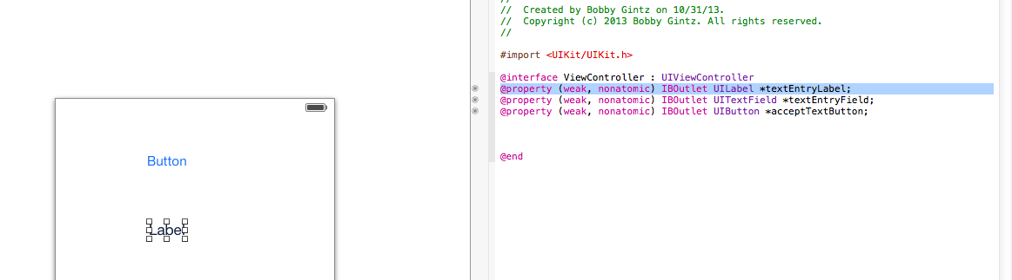
* 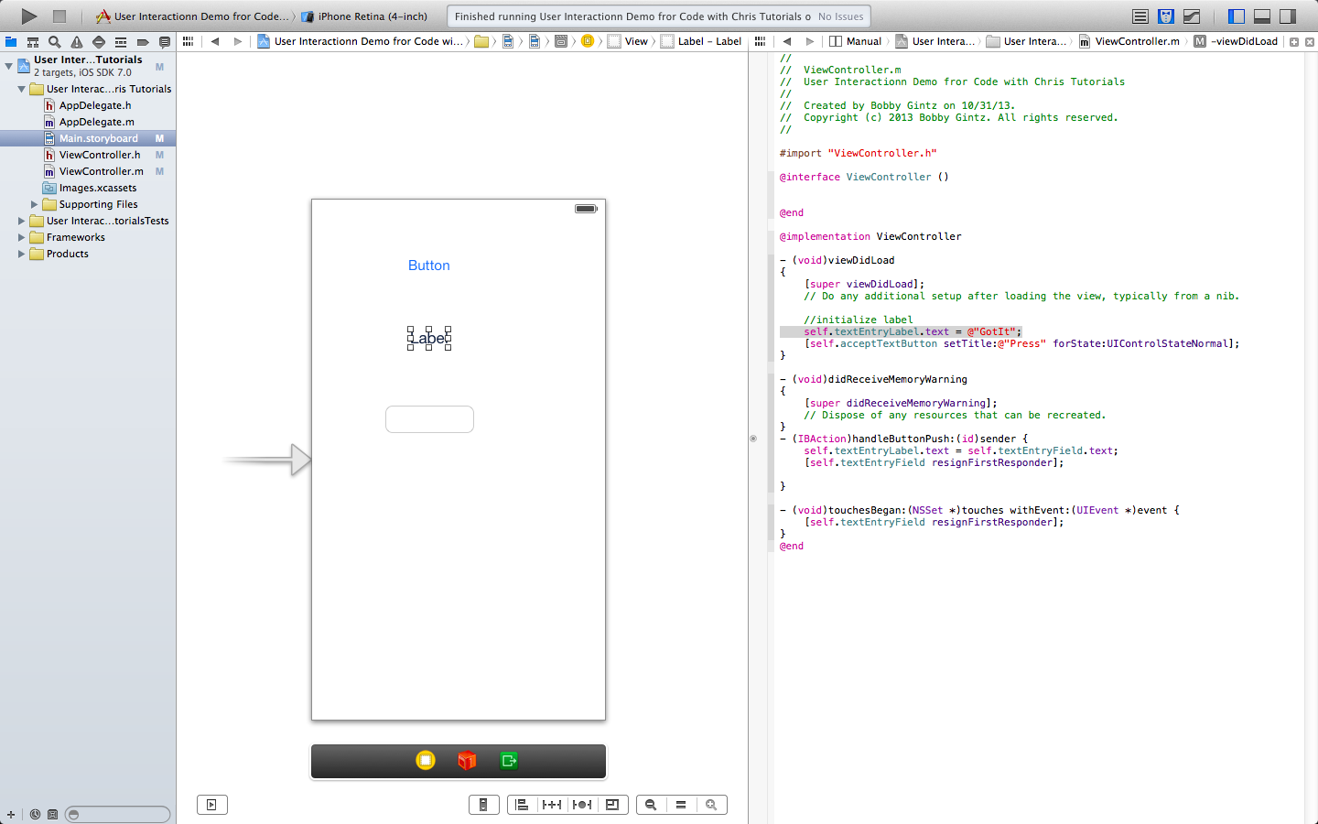
* In other words:
* Properties hold references to Objects (so you can REFER) to them
* IBOutlet says the property can be exposed to Interface Builder and connect to UI Elements. So the keyword IBOutlet says the label, button, textfield objects created can be referenced by the properties for these created in the referencing object. In this case the ViewController.
* 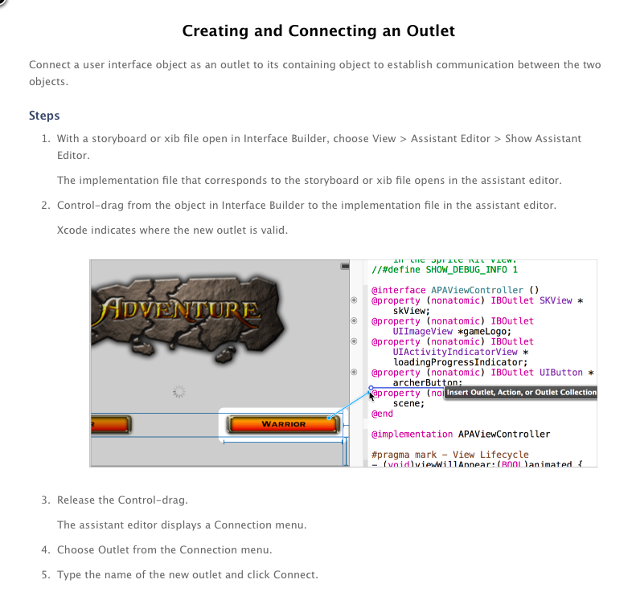
* IBAction is similar to IBOutlet. It is in the implementation file to provide a way to connect make actions associated with UIElements accessible from Interface Builder. This is how event handling is done.
* To create a method and connect with IBAction keyword yoi ctrl-click on the UI Object and drag into the implementation file
* SYNTAX LESSSON:
* Syntax for Manually Adding Properties to Objects (to reference other objects)
* In header file>
* 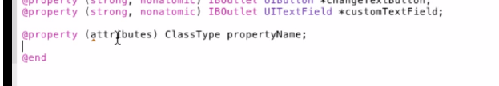
* Keyword @property
* Attributes: strong/weak, atomic/nonatomic,
* IBOutlet keyword only needed when hooking Oblect up to interface builder
* ClassType: i.e. UILabel,

*referenceName says this is a pointer to the object (address). Object names are referenced by their address. So if *pointerToBall references a Ball Object you can access its attributes, methods, etc by pointerToBall (no need to put the *)

SYNTAX LESSON: METHODS

* private methods can only be accessed by the Object that they were created in.
* reference by “self” keyword
* can make a method public by adding it to the class header file
* Chris says: “a header file is like a table of contents that other Objects refer to find what an Object offers”

Example:

Define the method in a Class

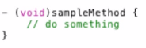

Call the method within the Class

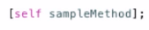

“-“ before the method indicates it is an instance method. i.e. every instance of the Object (i.e. every ViewControl Object will have this

“+” indicates Class or Static method

* **XCode Tutorial Practice 3: Storyboards, MapKit, View Navigation**
  + **Demonstrates creation of a model**
    - **create class to hold model data (i.e. PointOfInterest holds and address**
    - **create model controller class (LocationDataController**

IB Steps to Create Two Views and a Seque Between Them

* + Create a project
  + Created a View Controller (initial view)
  + Embed a Navigation Controller (editor🡪 embed🡪navigation controller
  + Add another View Controller for the MapView
    - Add a ViewController to the Storyboard
      * in IB drag it from object library
      * it will autogenerate a ViewController file
      * but we want to create our own ViewController class and attach it to the new View….
        + Create a Class MapViewController (subclass of UIViewController)
        + Now in the storyboard window select MapViewController
        + in Class Inspector set custom class to MapViewController
  + Add a button to the first view
  + Control-click drag from button into new VewController
    - So now we have a segue to switch from our initial view into the MapViewController view when the button is pressed’
* So now we need to create a Model:
  + 
* Creating the Model
  + The data will be encapsulated in a class called: Location
    - Create location (subclass of NSObject)
  + Create a Class to be our model:
    - LocationDataController (subclass of NSObject)
    - It will be in charge I supplying our view controllers with the data they will display
  + Give “Location” properties of the address (in Location.h)
  + 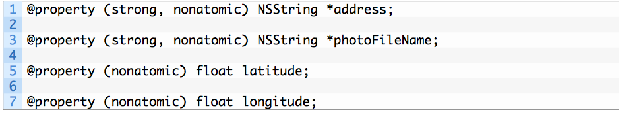
    - So each instance of Location can hold the data we want associated with a physical place (address, lat, long, etc)
    - Note: No methods in location
  + Now Implement a method in LocationDataController.m called getPointofInterestthat
    - instantiates a Location
    - Iniializes it (hardcoded for this example)
    - Returns Location (pointer to the Object
  + 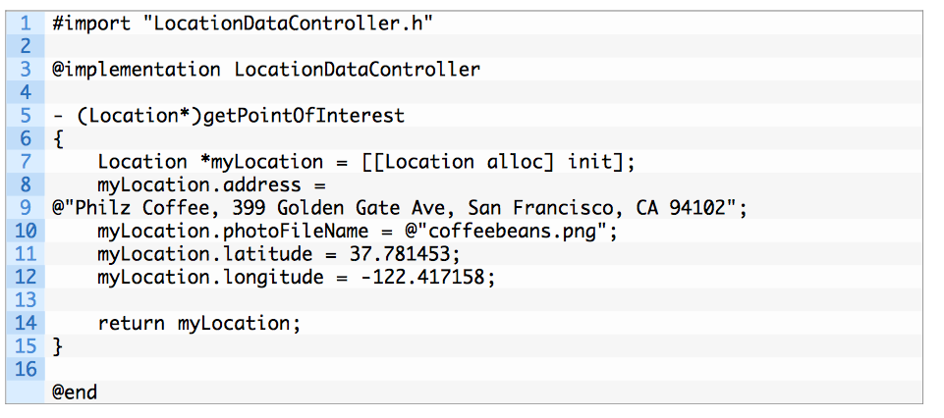
  + Multi-View App Flow Explained
    - View Controller was embedded in the Navigation Controller
    - Navigation Controller is a ViewController that manages other VC
    - AppDelegate had a reference to the NC
    - UINavigationController sets the first VC as the child of the NavigationController so tht NC can manage it
  + 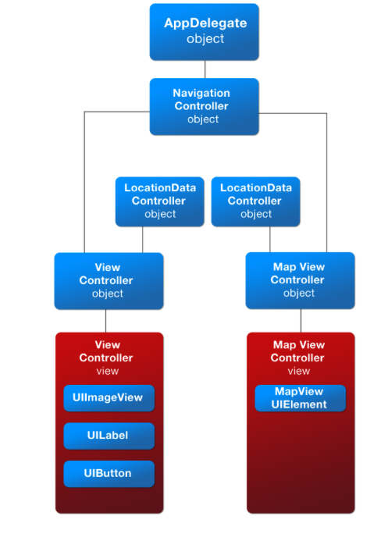
* **Multi-View App Flow**
* In the previous tutorial, we introduced Storyboards and you saw how easily we could hook up two views and navigate between them.
* The app flow looked like this:
* 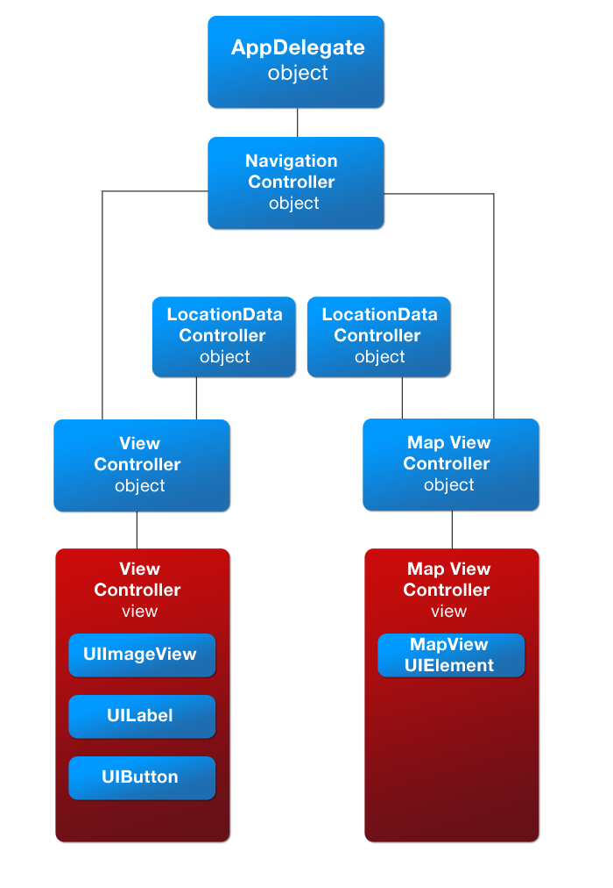
* Do you remember when you selected the first ViewController and selected a menu option called “Embed In Navigation Controller”?
* What that effectively does, is create a UINavigationController and then sets that first ViewController as a child of the Navigation Controller so that the Navigation Controller can manage it.
* Then instead of the AppDelegate having a reference to the single ViewController, it sets the AppDelegate to hold a reference to the Navigation Controller.
* That’s how you end up with the app flow in the diagram above.
* **What’s a Navigation Controller?**
* So what is a navigation view controller? It’s a special UIViewController that manages other viewcontrollers (Apple Doc [here](https://developer.apple.com/library/ios/documentation/uikit/reference/UINavigationController_Class/Reference/Reference.html)).
* It has a property called “viewControllers” which acts like a bucket for ViewControllers that you can add to or remove from.
* The Navigation Controller also provides methods to transition between any of the ViewControllers in the “bucket”.
* **Navigation Controller’s ViewController Stack**
* The “bucket” actually behaves more like a stack of papers. When ViewControllers are added to the stack, they are at the top of the stack.
* In order to get to the ViewControllers below, you have to remove the ones above it.
* Also, the ViewController at the top of the stack is the ViewController that is visible.
* **What’s a “push” Transition?**
* Remember when you hooked up the button in the first ViewController to transition to the second ViewController? We chose the option “push” for that transition.
* What’s happening is the following:
* Initially you only have the first ViewController in the stack so it’s visible to the user
* 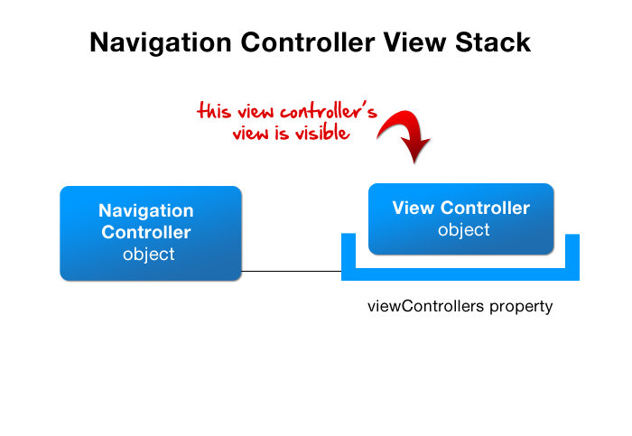
* Then when the user clicks the button, the second ViewController gets added to the top of the stack so now the second ViewController is what the user sees.
* 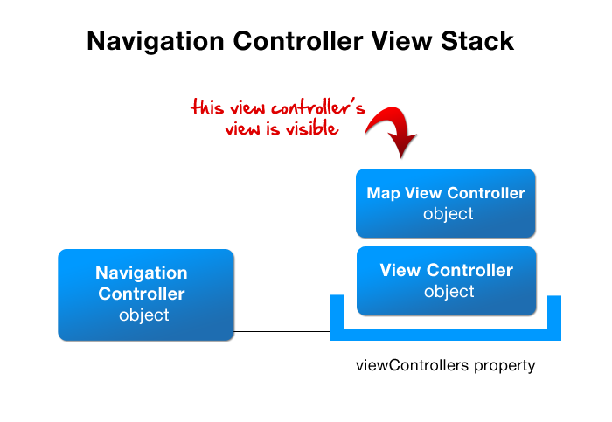
* Then when the user hits the “back” button, the top ViewController gets removed, and the user once again is looking at the first ViewController
* 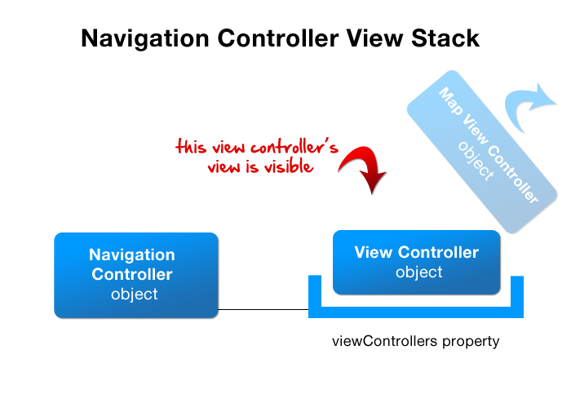
* **Modal transition**
* Another option is to present the second ViewController as a modal of the first ViewController.
* You see, ViewControllers have an ability to present another ViewController as a modal and it looks like this:
* 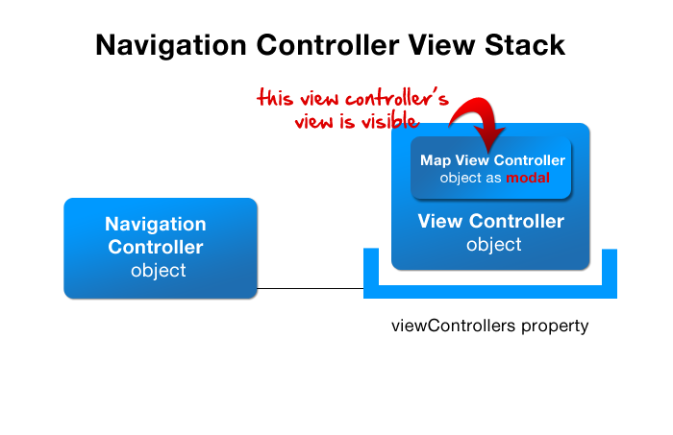
* In this case, the first ViewController has a reference to the second ViewController and it controls whether the second ViewController is displayed or not.
* In the “push” case, the navigation controller has a reference to both ViewControllers so it’s the “parent” of both of them.
* You can read more about how to use Modal ViewControllers in the Apple Documentation, [Presenting View Controllers from Other View Controllers](https://developer.apple.com/library/ios/featuredarticles/ViewControllerPGforiPhoneOS/ModalViewControllers/ModalViewControllers.html).
* More on Modal vs. Push:
* 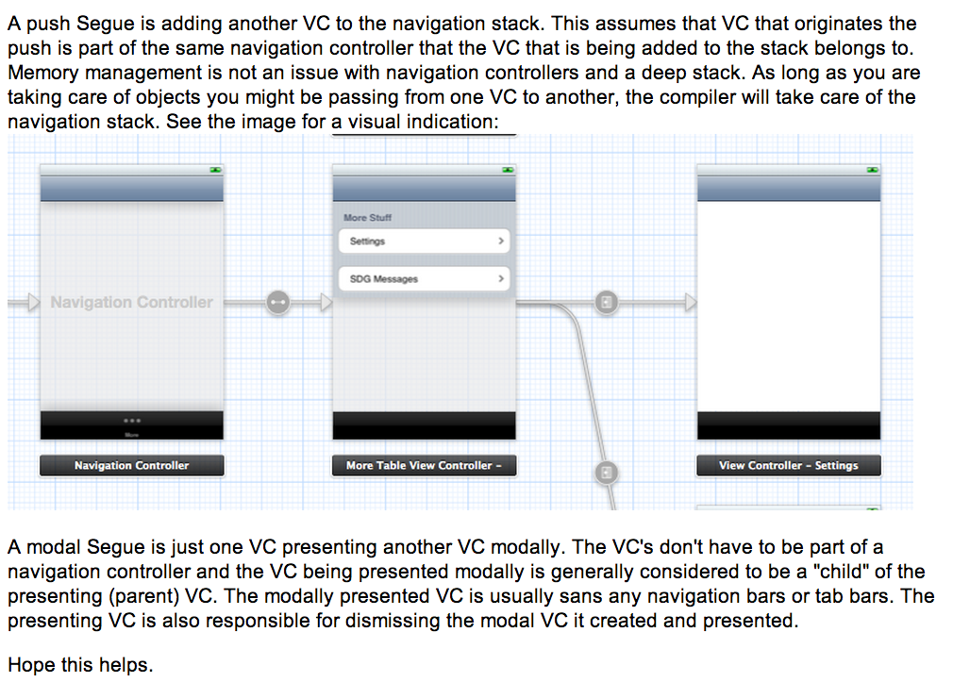
* ­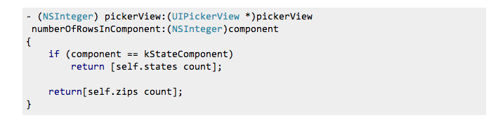
* 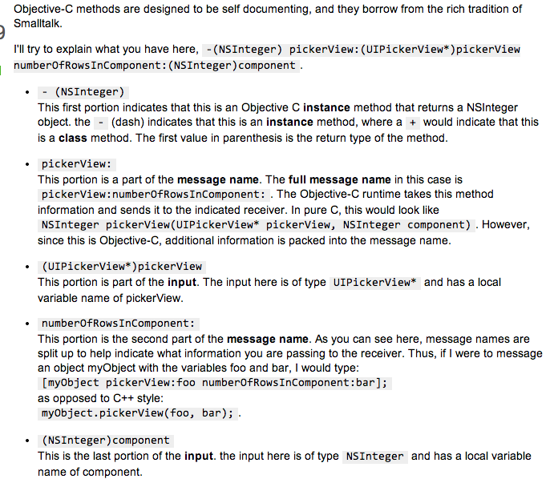
* <http://cocoadevcentral.com/d/learn_objectivec/>
* label : (parameter type) parameter
* 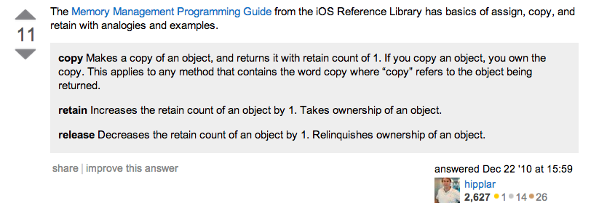
* This was old MMR (Manual Retain Release) which was superceded by ARC (Automatic) memory management
* <https://developer.apple.com/library/mac/documentation/Cocoa/Conceptual/MemoryMgmt/Articles/MemoryMgmt.html>
* alloc sets retain counter to 1
* retain increases it
* release decreases it
* dealloc releases the memory
* STRONG vs WEAK
* The difference is that an object will be deallocated as soon as there are no **strong** pointers to it. Even if weak pointers point to it, once the last strong pointer is gone, the object will be deallocated, and all remaining weak pointers will be zeroed out.
* Perhaps an example is in order.
* Imagine our object is a dog, and that the dog wants to run away (be deallocated).
* Strong pointers are like a leash on the dog. As long as you have the leash attached to the dog, the dog will not run away. If five people attach their leash to one dog, (five strong pointers to one object), then the dog will not run away until all five leashes are detached.
* Weak pointers, on the other hand, are like little kids pointing at the dog and saying "Look! A dog!" As long as the dog is still on the leash, the little kids can still see the dog, and they'll still point to it. As soon as all the leashes are detached, though, the dog runs away no matter how many little kids are pointing to it.
* As soon as the last strong pointer (leash) no longer points to an object, the object will be deallocated, and all weak pointers will be zeroed out.
* <http://www.idev101.com/code/User_Interface/sizes.html>
* 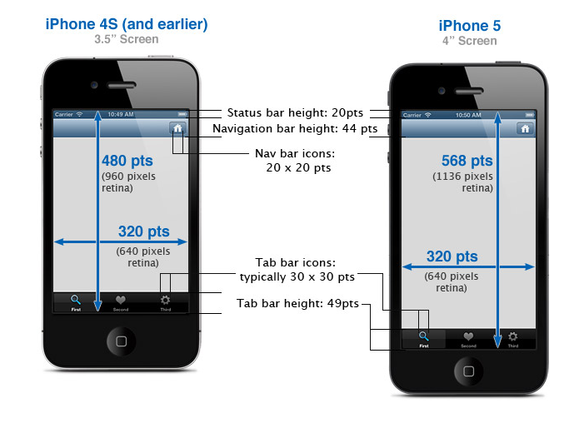
* 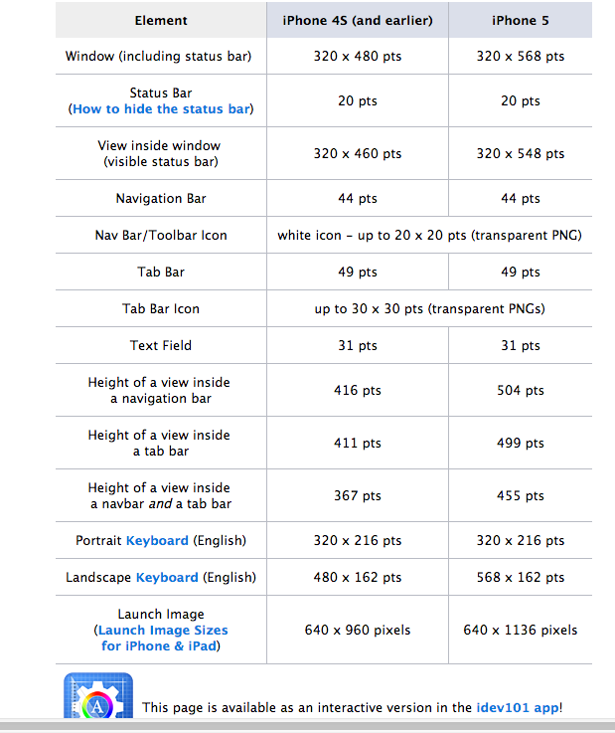
* <https://developer.apple.com/library/safari/documentation/UserExperience/Conceptual/MobileHIG/index.html>
* 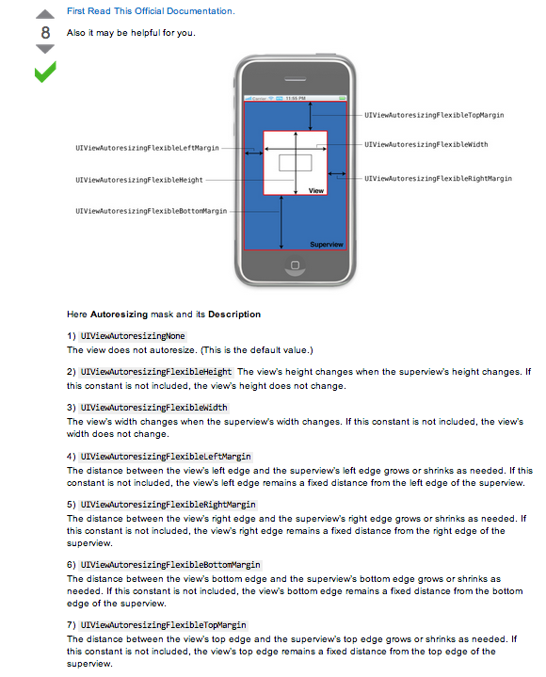
* From Video:

WWDC 2013 Video on debugging in Xcode 5

* 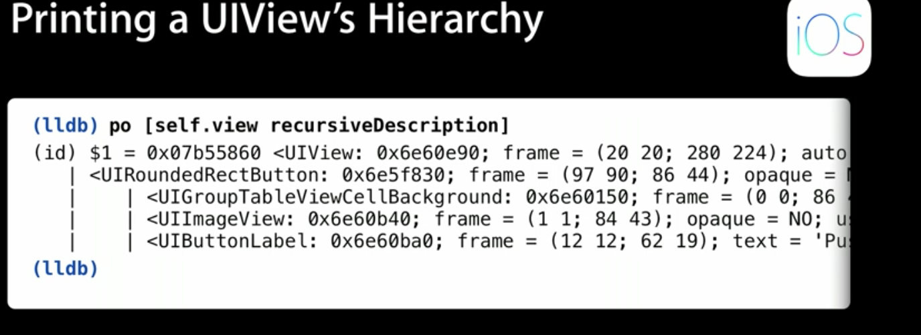
* LLDB (from 2012 WWDC video)
* <https://developer.apple.com/videos/wwdc/2012/?id=415>
* 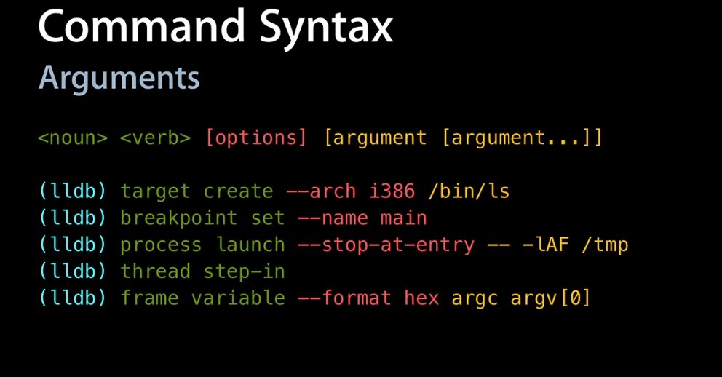
* 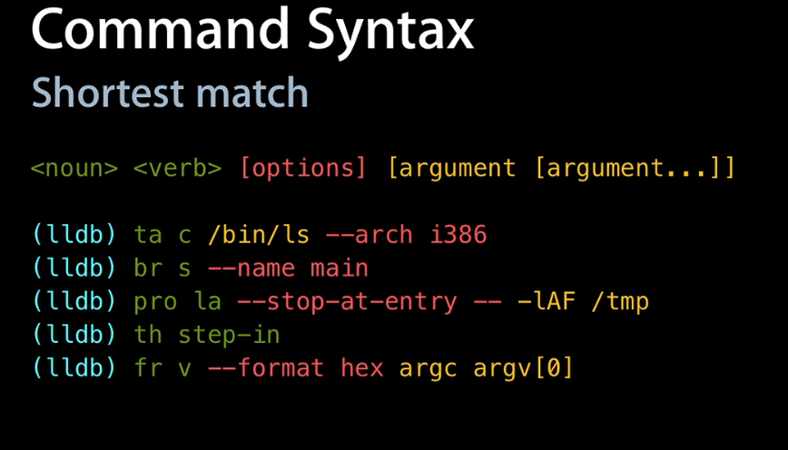
* Hit TAB after noun to see what you can do with it
* Can debug two targets at the same time
* 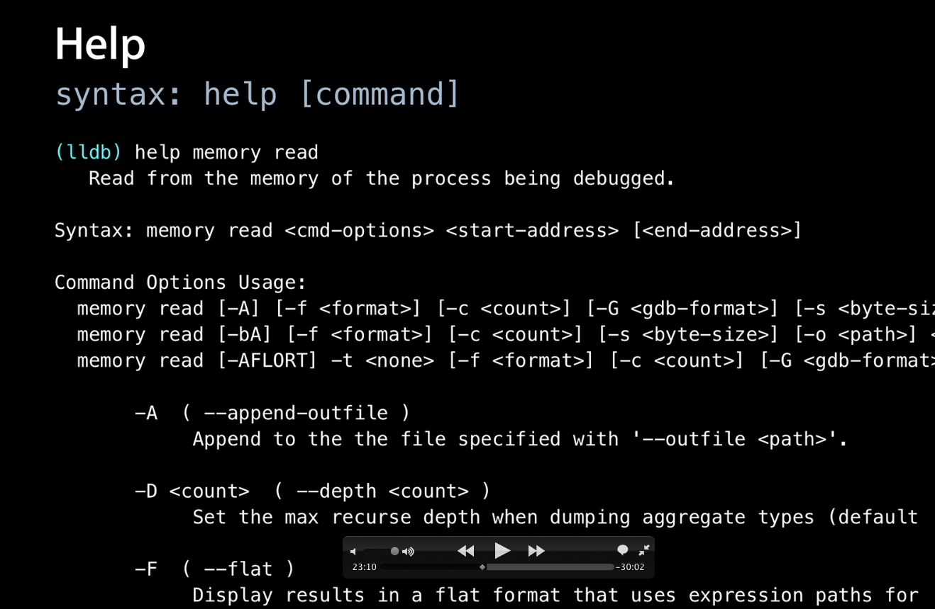
* 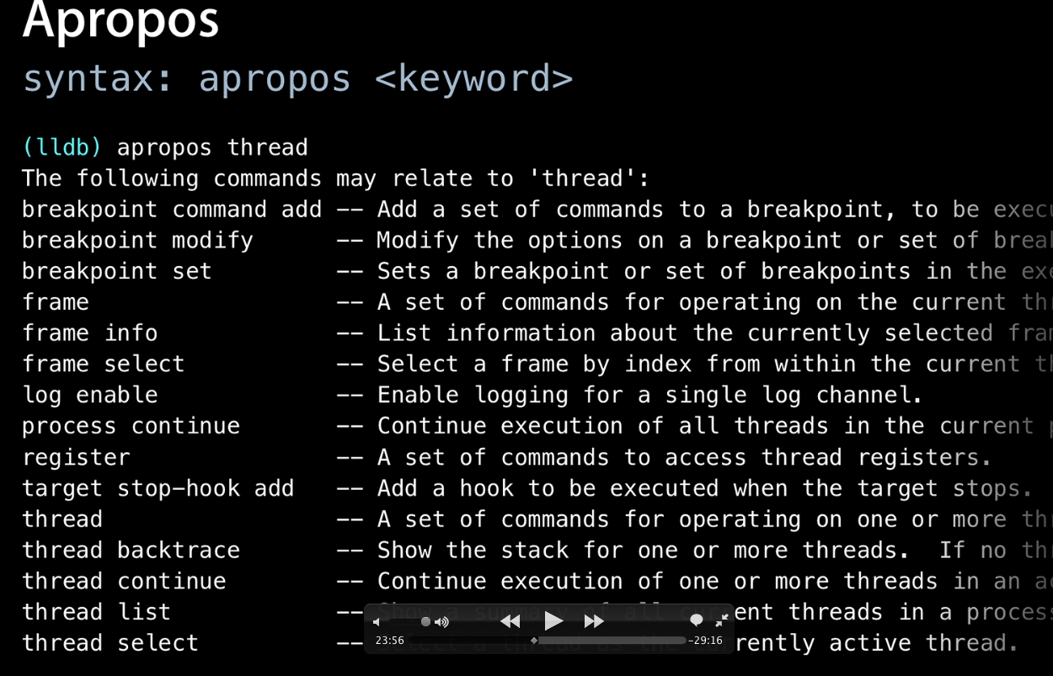
* Create expressions which are evaluated inline (just as if they were part of the code)!
* 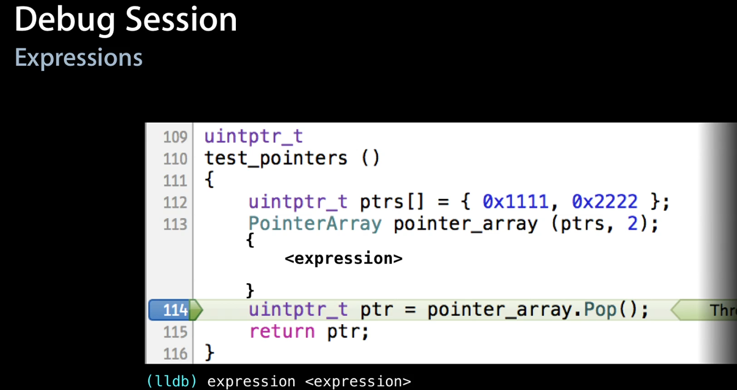
* 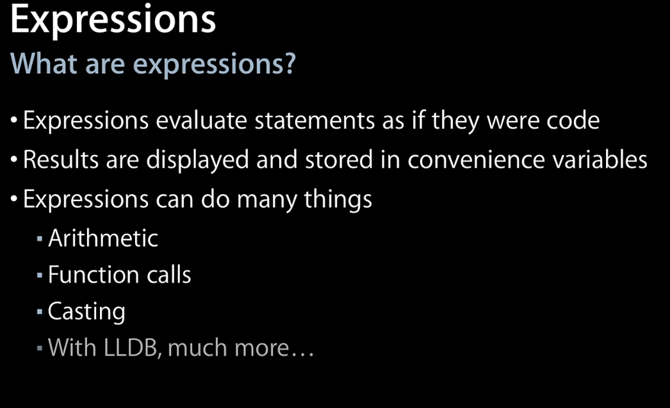
* I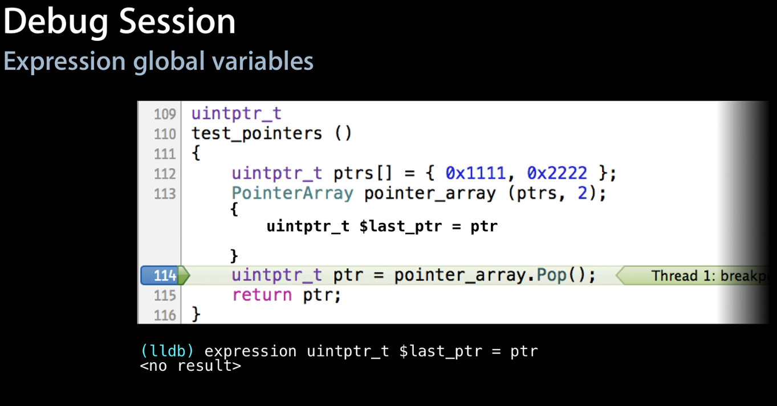If create a variable with a $ it will persist for more than just the current expression (global variable)
* Use it for debug output:
* 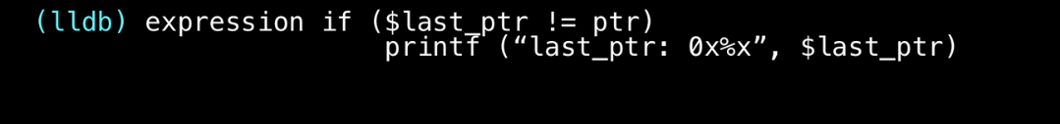
* Use this to find out why expression doesn’t work
* 
* Make the problem happen in the expression without modifying the code (compiler evaluates the expression until it fails)
* 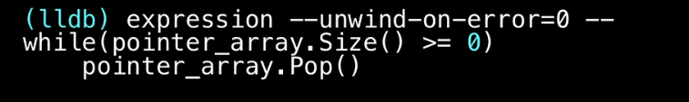

** Also can uses this to test out boundary conditions of function by calling with high number, low number, etc!!

* + Set breakpoints in code
  + Use unwind on error option
  + Set it to stop on the breakpoints and explore while evaluating the expression without injecting the code into the program
* Since we have the compiler integrated with lldb, we can ask the compiler for answers like: what is the size of a defined data type:
* 

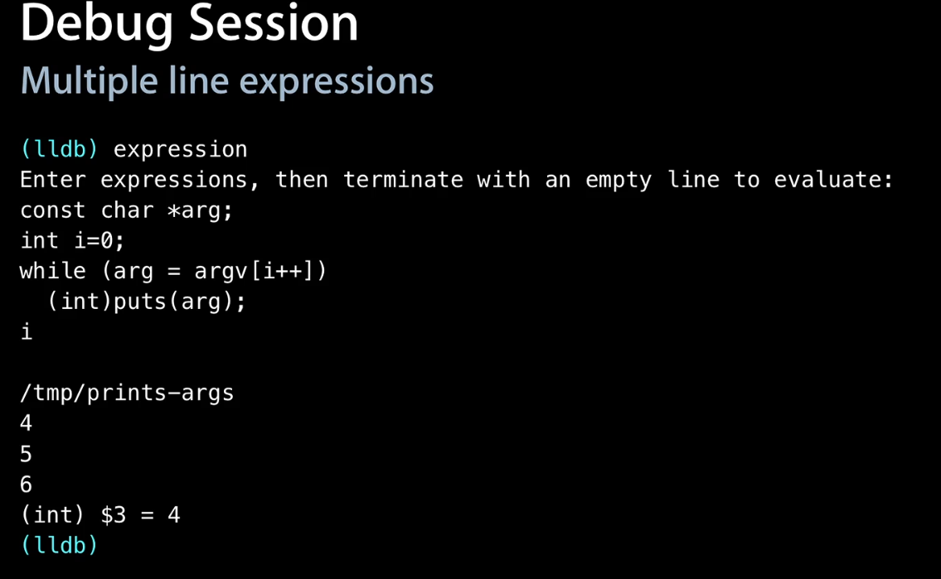

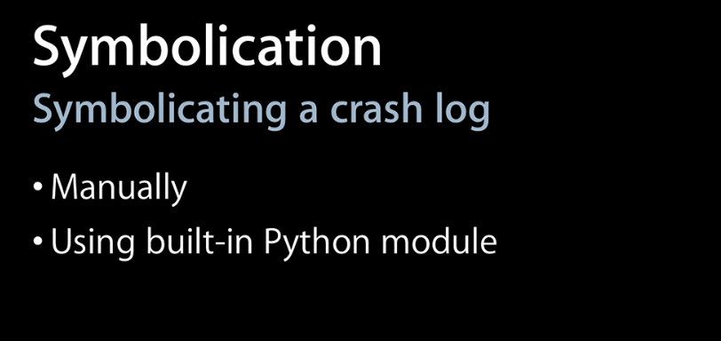

Manual Method:

* + Create a target to debug
  + Add shared libraries (so they can be symbolicated)

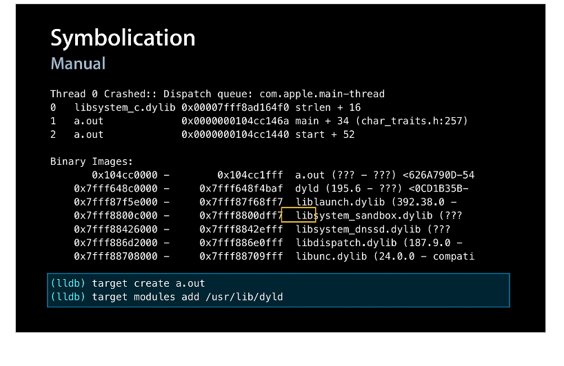

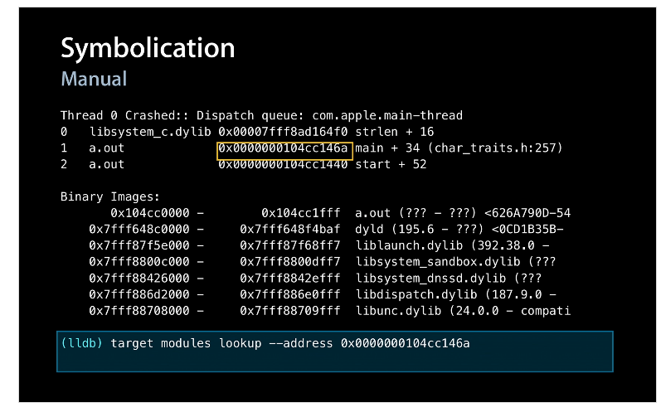

Lookup the crashed address in the crashlog

* + Three stack frames unwound
  + Crashed at main.cpp line 11: (see below)

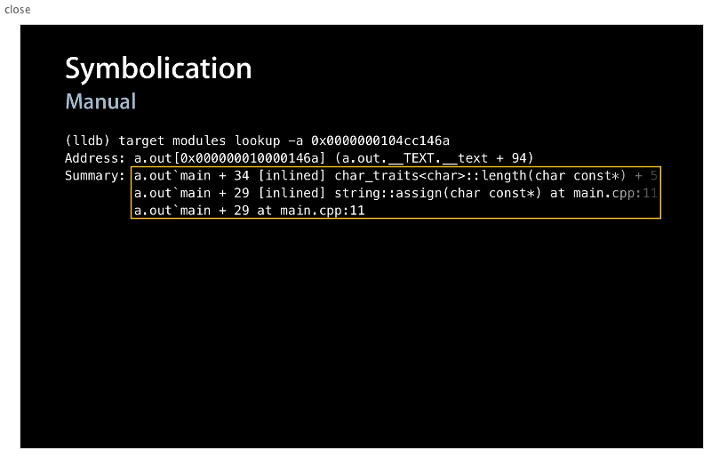

NOW USE PYTHON MODULE TO DO CRASHLOG ANALYSIS:

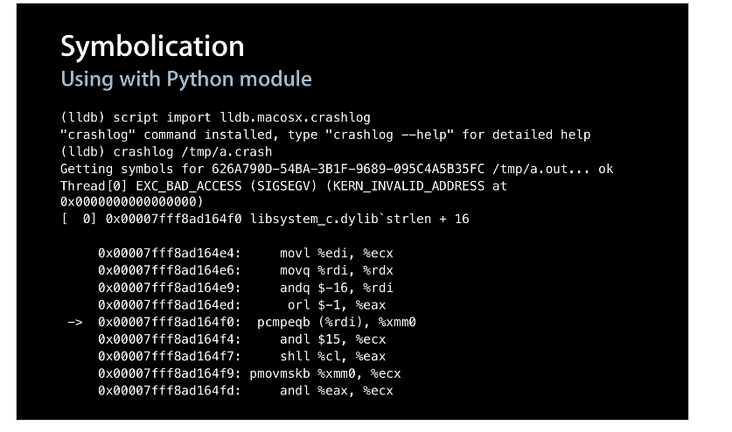

* + Import crashlog python script (new “crashlog” command is now available)
  + run crashlog on the log (a.out has a crashlog of a.crash)
  + Automatically symbolicates the stack frame (see above for SF 0)
  + End of stack trace shows crash at main.cpp line 11

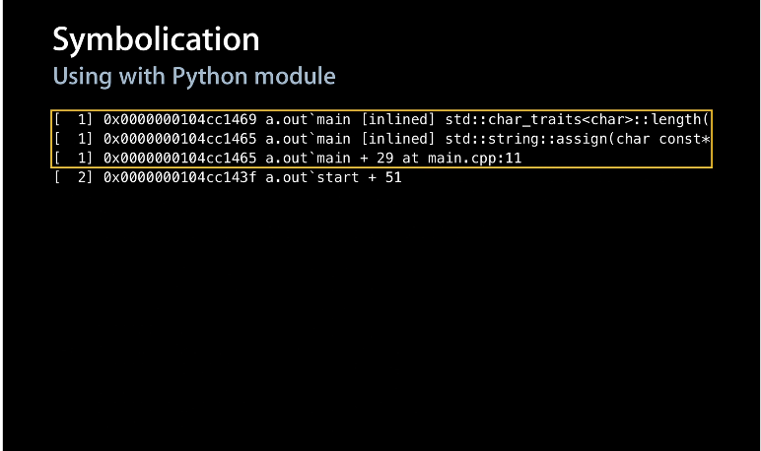

Other modules:

* Commands:
* <https://developer.apple.com/library/ios/documentation/IDEs/Conceptual/gdb_to_lldb_transition_guide/document/lldb-command-examples.html#//apple_ref/doc/uid/TP40012917-CH3-SW1>
* <http://lldb.llvm.org/tutorial.html>
* <http://www.slideshare.net/jmjeong/lldb-introduction>
* 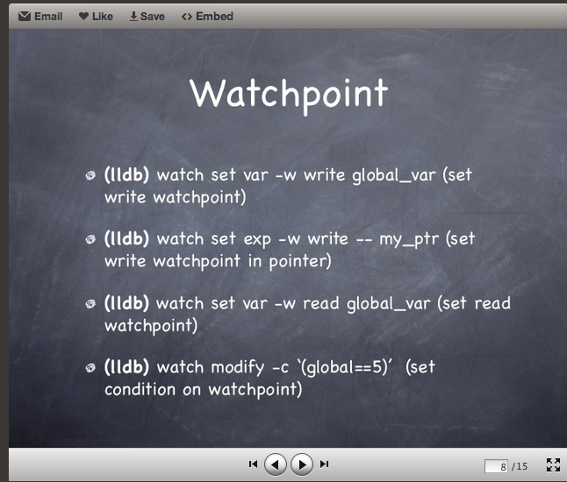
* 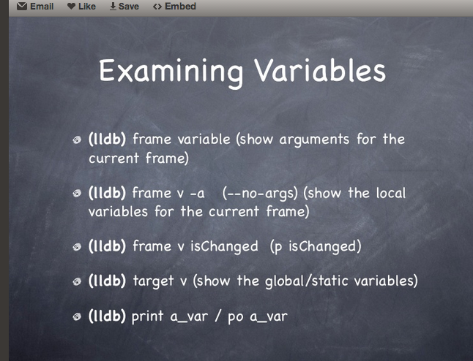
* 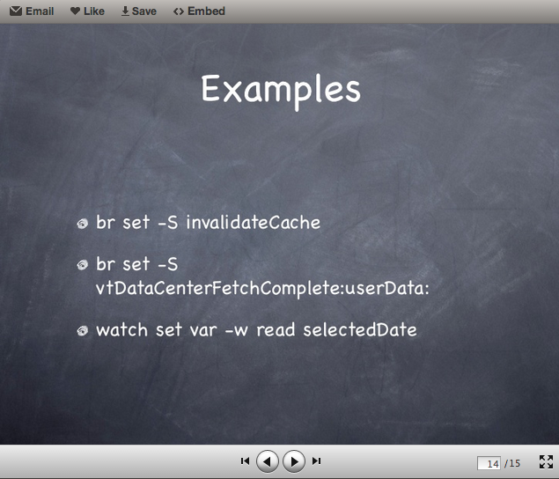
* Part 2
* <http://www.youtube.com/watch?v=ZoTAKAjEIFM>
* Add entities to data model
  + precede attribute name in lowercase for entity name
  + don’t put plurals for entity name
  + relationships can be plural if one to many
  + spelling of attribute names need to match the spellings used in the UI for fields
  + A patient can have many prescriptions
  + A prescription is written and specific to one patient
  + One to many from patient to prescription
  + 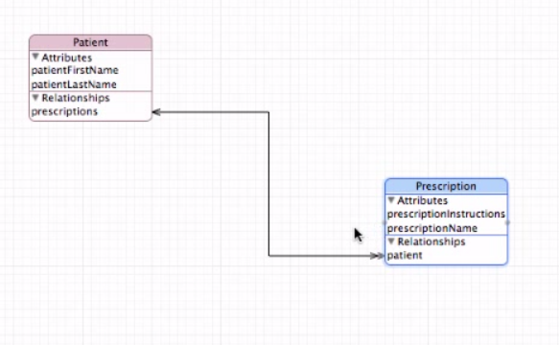
* Create the NSManagedObjects
* Select them at the same time and Edit menu:
* 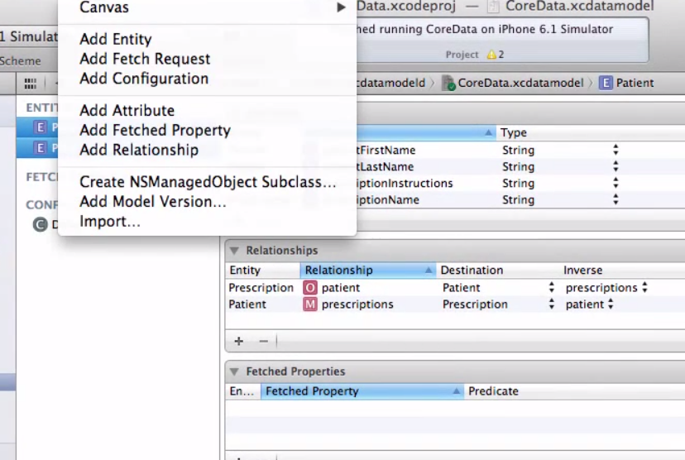
* What got created:
* 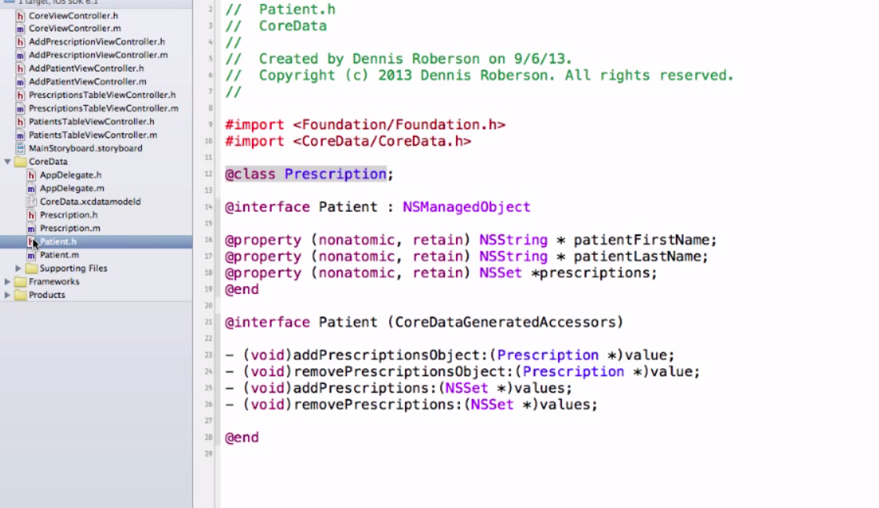
* Note Xcode generated a forward class to Prescription but this is backwards because Patient will reference prescription. If this happens, delete the class files and regenerate again from the data model (note maybe this is because he did not do them one at a time)
  + Note that Patient inherits from NSManagedObject not just NSObject
* Patient.m:
* 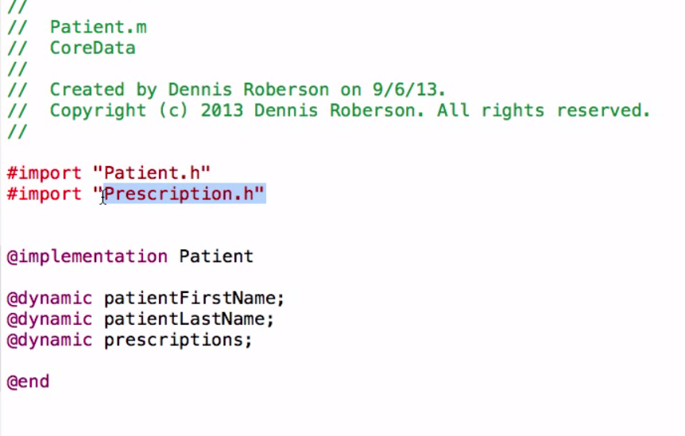

Dynamic means the property accessors are created at runtime not synthesized by compiler

Header file is imported

* Now must have the view controller.h conform to NSFetchedResultsControler Delegate Protocol and add property to reference a patient
* 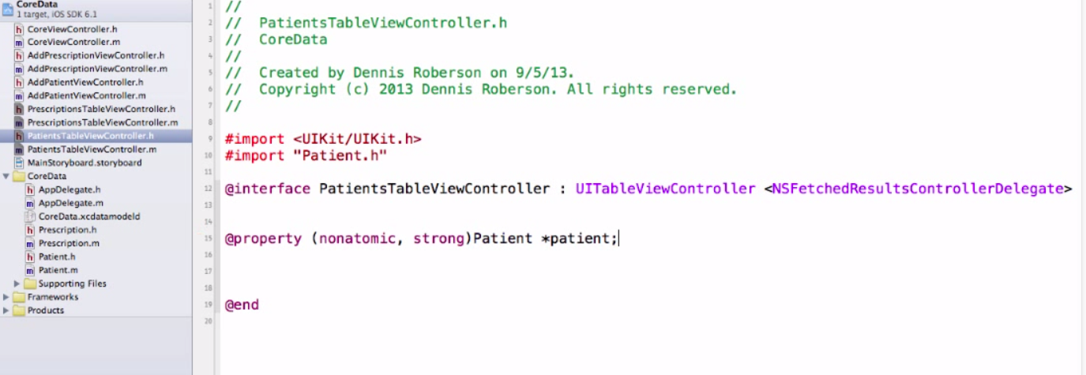
* In implementation file need to import
  + AppDelegate to have access to our core data stack
  + AddPatientViewController
* Also add properties for NSMOC and FRC:
* 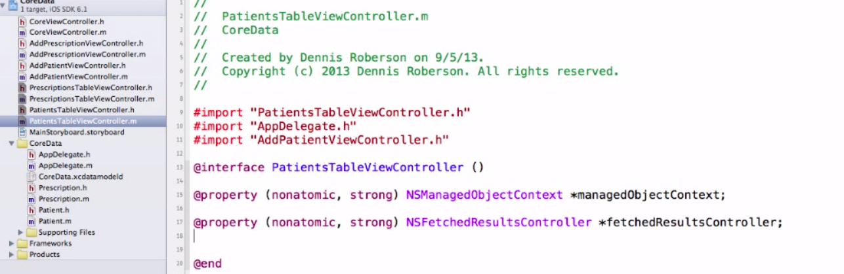
  + In order to get data from the MOC we need to execute a “FectRequest”
  + Fetch request returns an array of Objects and in our case will return an array of Patient Names (returned in no particular order)
  + Fetched results controller ties the fetched results to a UITableView
* Need a reference to the NSManagedObjectCOntext so create the method:

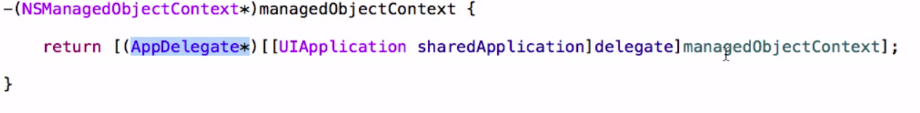

Add FRC Section – The FRC ties the fetched result into the TableView

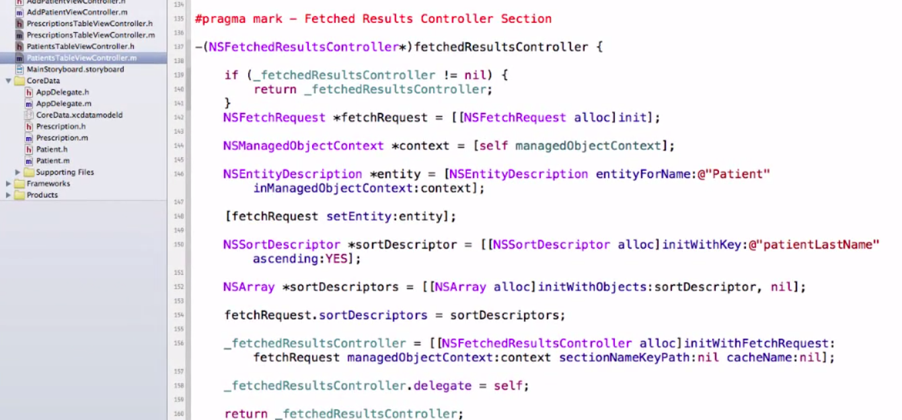

* + create a fetch request
  + set the managed object context
  + create an entity description and set the entity of the fetch request to that entity
  + create a sort descriptor which requests “Patient” entities attribute patientLastName sorted in ascending order
  + create an array of the sort descriptor objets
  + set the fetchRequest sort descriptoed to the array
  + create the fetchedResultsController with the fetch request on the MOC
  + return the FRC
* NOW need to update the TableView Controller Data Source:
  + “numberOfSectionsinTableView and
  + numberOfRowsInSection:
* 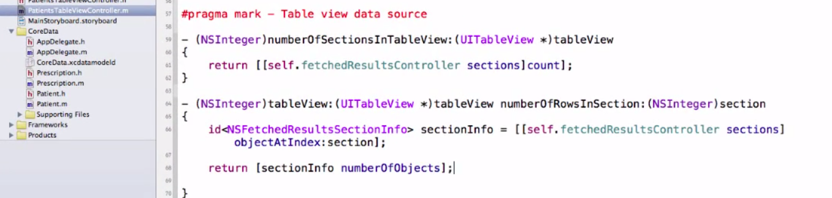
* Set cell style as Subtitle so can list patientLastName as primary text
* 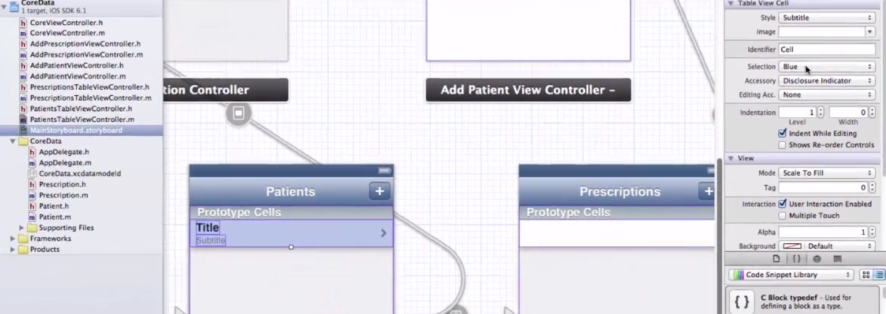
* Also verify the reuse identifier of the cell:
* 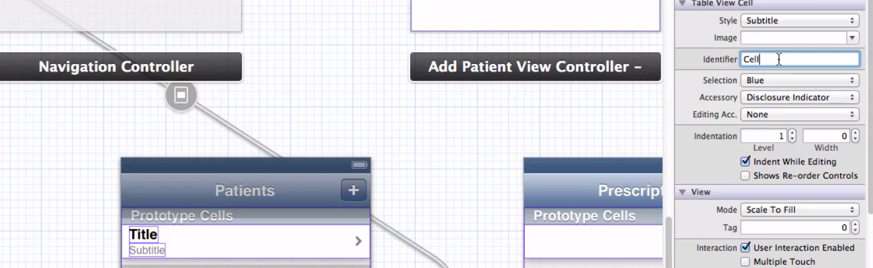
* Back to Data Source: cellForRowAtIndex edit the method to :
* 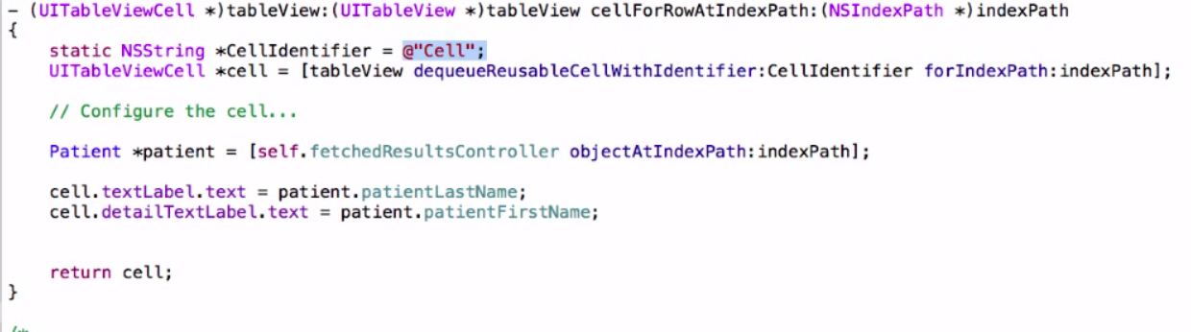
* NEXT: viewDidLoad method in the PatientsTVC
  + coded similarly to the save method in the CoreViewController
  + This will fetch the results for display by the TVC
  + The FRC will have the array of objects which will be used to fill in the cells in the cellForRowAtIndexPath…
* 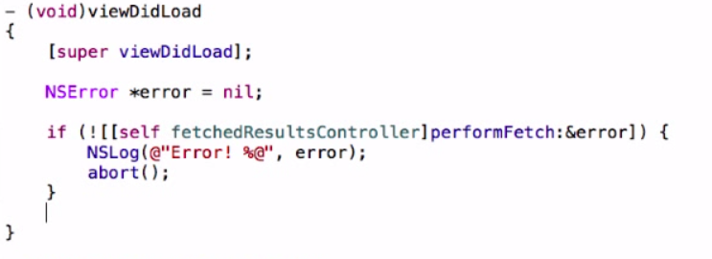
* Test the app – OK, but no data exists yet. So we need to add an object.
  + Add a prepare for segue method to the AddPatientViewController
  + There could be multiple segues from PatientViewController so check identifier first
  + Then get need to define the destination
  + We imported AddPatient.h so we can make it the destination
  + Next we get a pointer to the AddPatientViewController and set it be topViewController of a navigationController and cast it as an AddPatientViewController
  + Create a new Patient Object and Insert it into the MOC
* 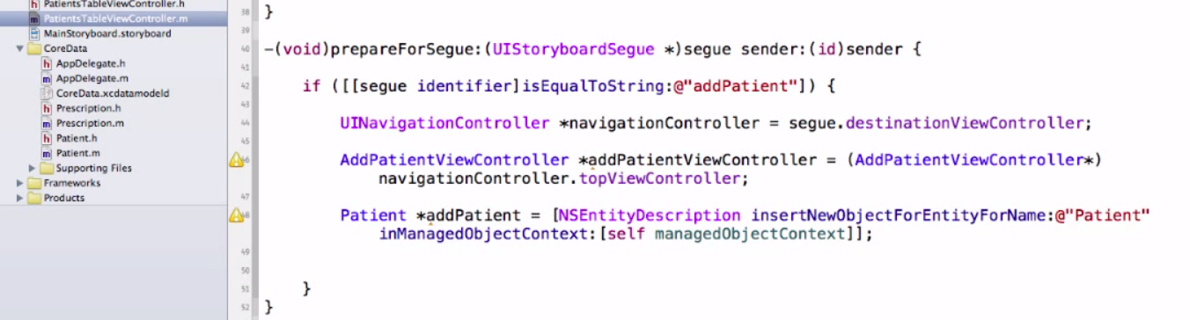
* *** So we want to pass the new Patient Object to the AddPatientVC but need to edit the header file to accept this first:
  + import Patient Class
  + Add a property for the addPatient Object
* 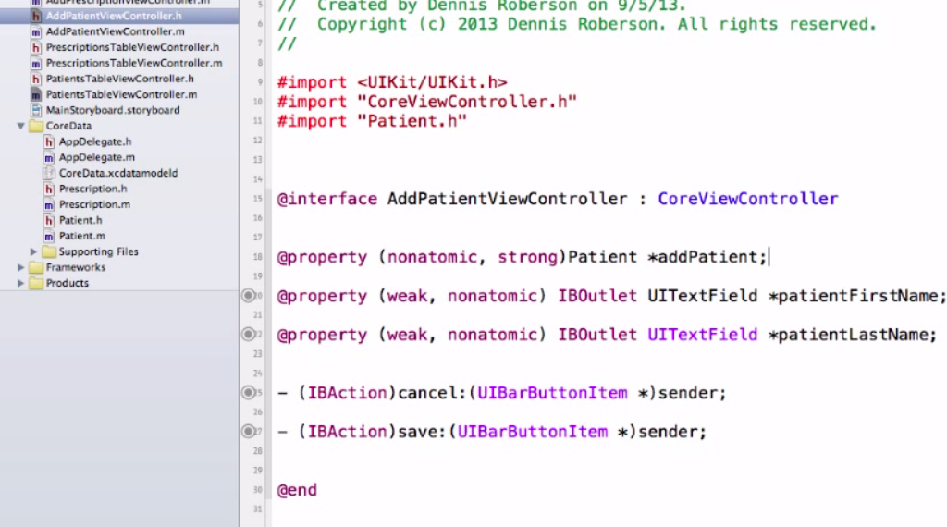
* Back to the PatientTVC:
* 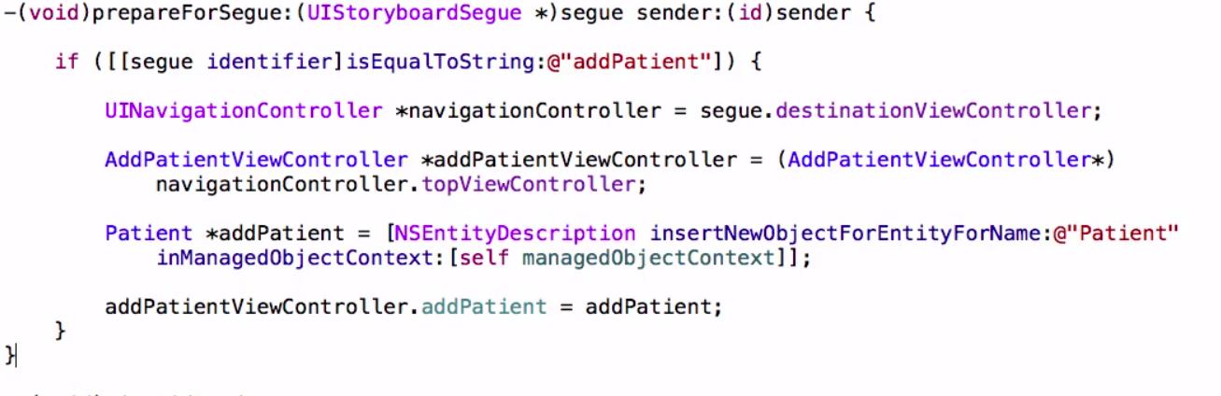
* In the last line: we set the addPatient property we just created in the AddPatientViewController to point to the addPatient Object we just created in the line above.
* Now we need to synthesize the property we added to the AddPatient.h file in the AddPatientViewController.m file so we have accessor methods for the object “addPatient”
* 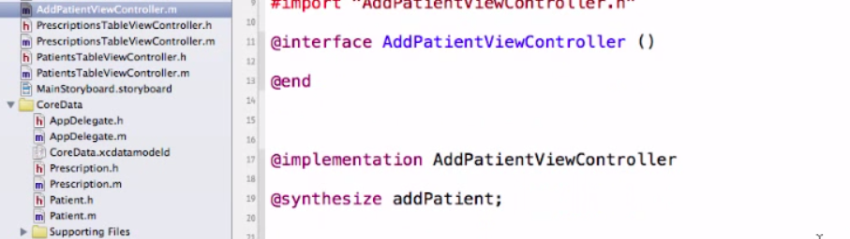
* So now we can save the data when a user updates the text fields by editing the save method:
* 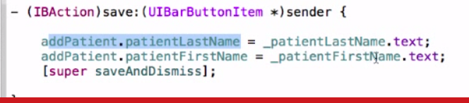
* Explanation:
* We are taking the text that the user entered into the patientLastName text box and assigning it to the patientLastName attribute of the addPatient Object, doing the same with first name.
* Build and Test: Data was saved but not displayed.
* So we need to add the **FetchedResultsController delegate** methods (these are used to update the TableView from the fetched results
* 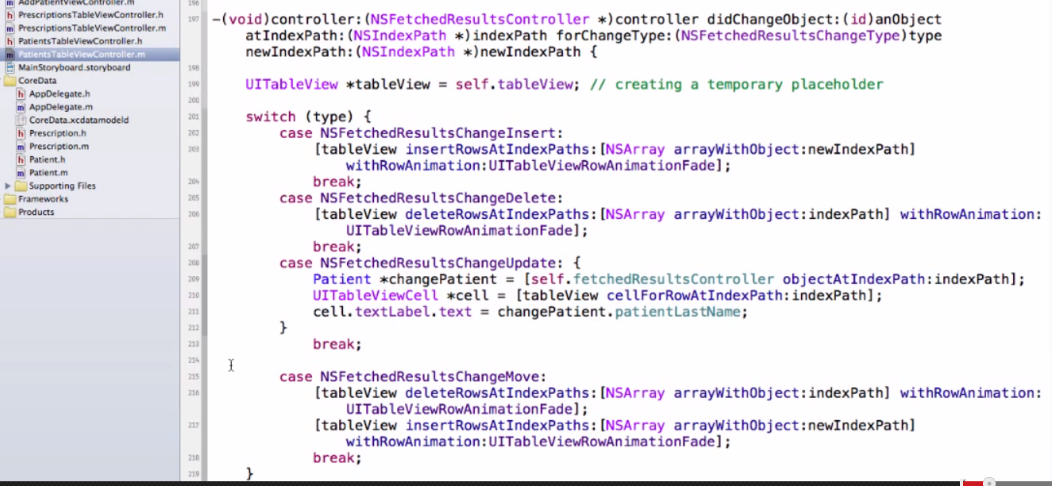
* For changes in Sections use the following code snippets:
* 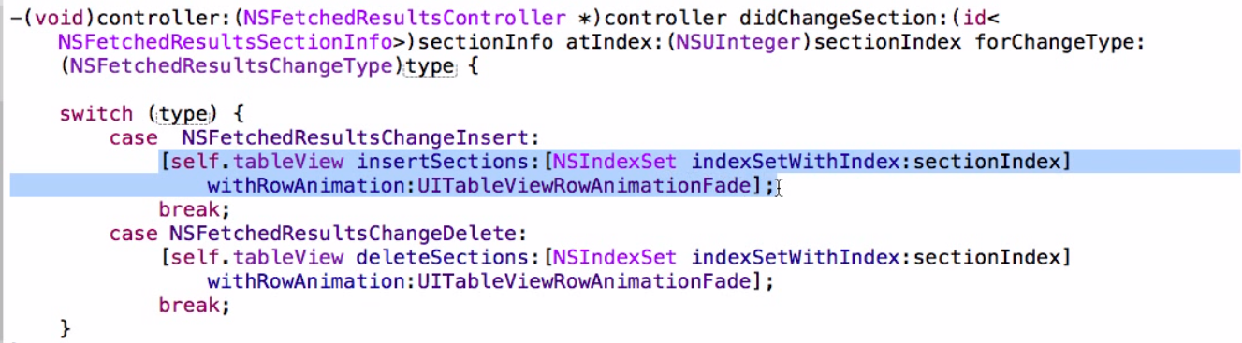
* Build and run and updates work but still no selete. This is in the TableView Data Source
  + Uncomment override to support editing the table view
* 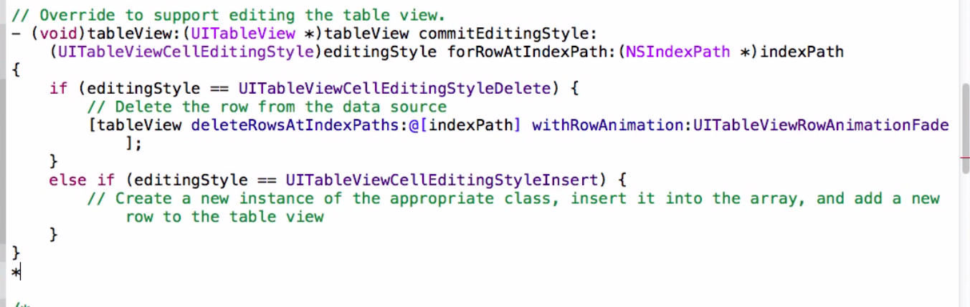
* Delete the editingStyle (we already handled that in the FetchedResultsCOntroller
* Also delete the call to deleteRowsAtIndexPaths
* Ad here is what the code to execute the delete using the managedObjectContext looks like:
* 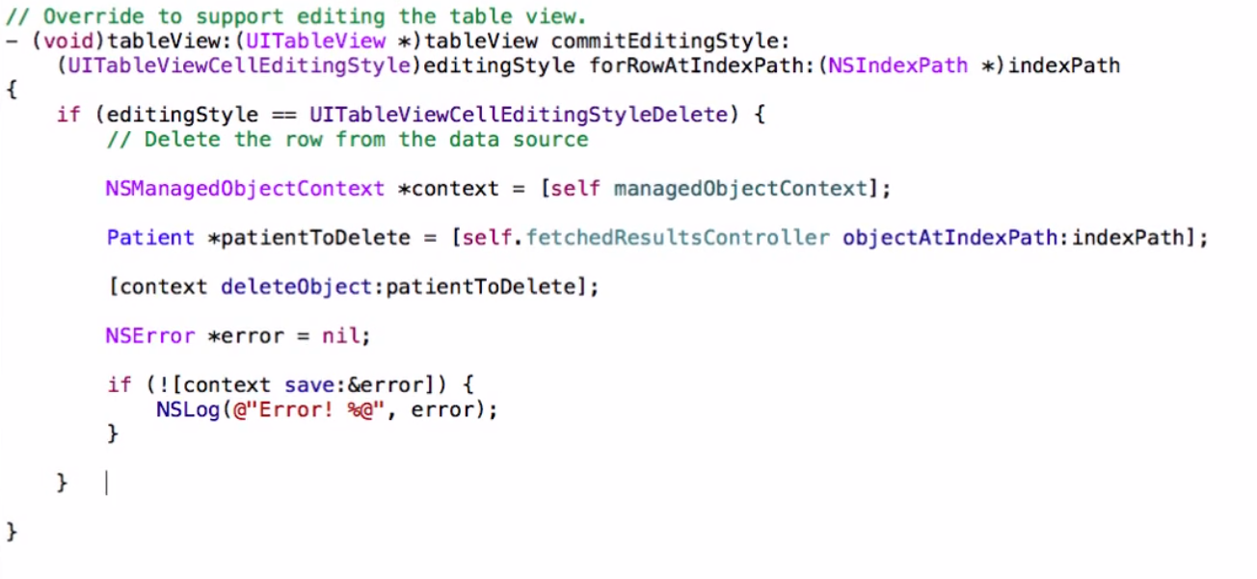
* PART 3 – Coding The Prescriptions View Controller
* <http://www.youtube.com/watch?v=55GyePwgFVQ>
* IN PatientsTableViewController.m
* Add the following method to assure that no matter where we come from we always have updated data in the tableView
* 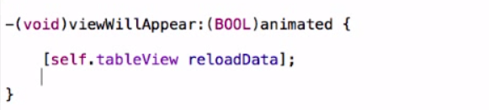
* Next import: PrescriptionsTableViewController
* Now we want to code the transition from PatientsTableViewController to PrescriptonsTVC:
  + prepare for segue:
  + First check on the segue name in the storyboard:
  + Click on the segue and look in property inpector
* 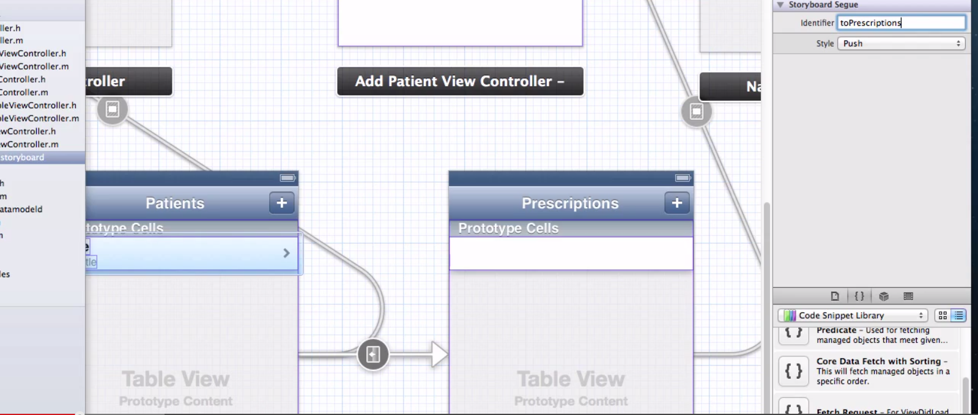
* So check for this segue indentifier and set the segue’s destinationViewController
* 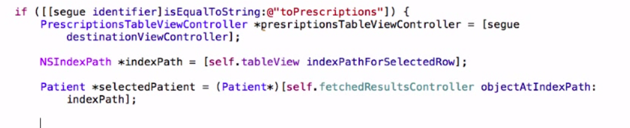
* Now need to jump over to PrescriptionsTVC and add
  + a couple of import statements – Prescriptions.h, Patient.h
  + class will conform to the NSFetchedResultsController protocol so add it here <> brackets
* 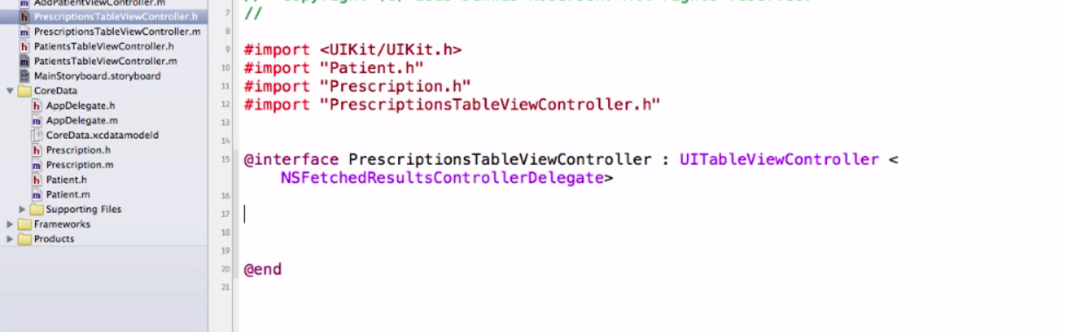
  + This controller will be passed a new Patient object in the segue so we need to create a property for this patient
* 
* Back to PatientsTVC prepareFor Segue and we can reference to property (last line below)
* 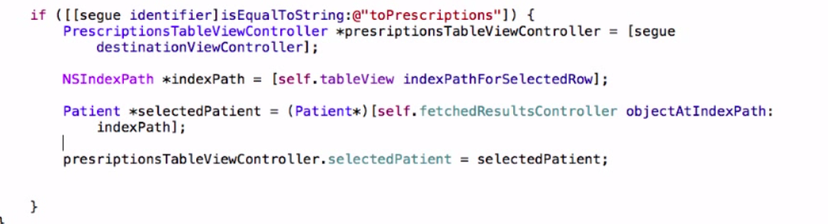
* So now we are done with Ptients will need to code the PrescriptionsTableViewController.m
  + Need access to the managedDataObject stack so import AppDelegate
  + Also need to access AddPrescriptionViewController
  + Need access to the MOC so add it in the private section of the file
  + Also one for FetchedResults Controller
  + Synthesize the object created in the header
* 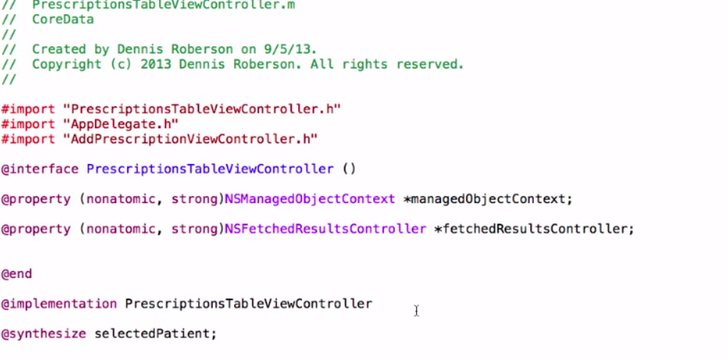
* Access to ManagedObjectContext as before:
* 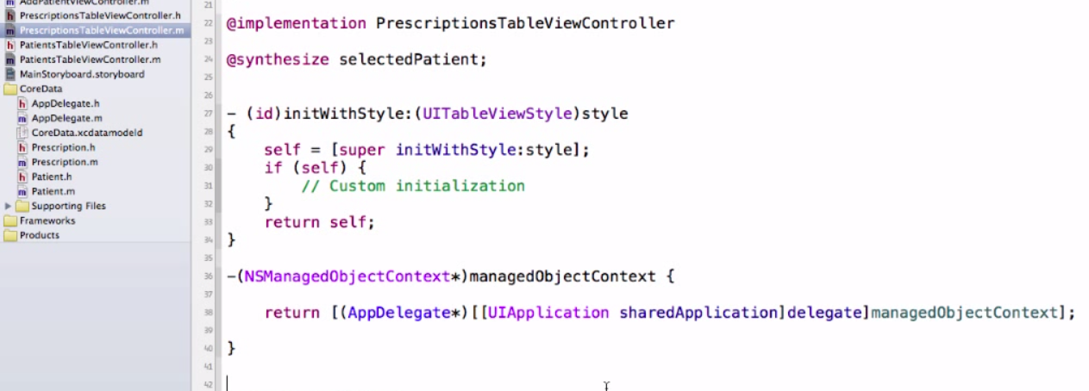
* Need a FetchedResultsController section:
  + copy it and the delegate and edit to change references from the Patient record (we copied from) to Prescription
  + Since we only want Prescription records for a specific Patient we need to code this as a **FetchPredicate**
  + This tells the FetchedResultsController to just give back results for the selectedPatient
* 
* Then set the predicate:
* 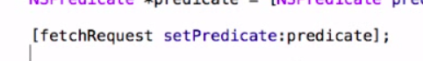
* So these are the only two additions and the FetchedResultsController looks like:
* 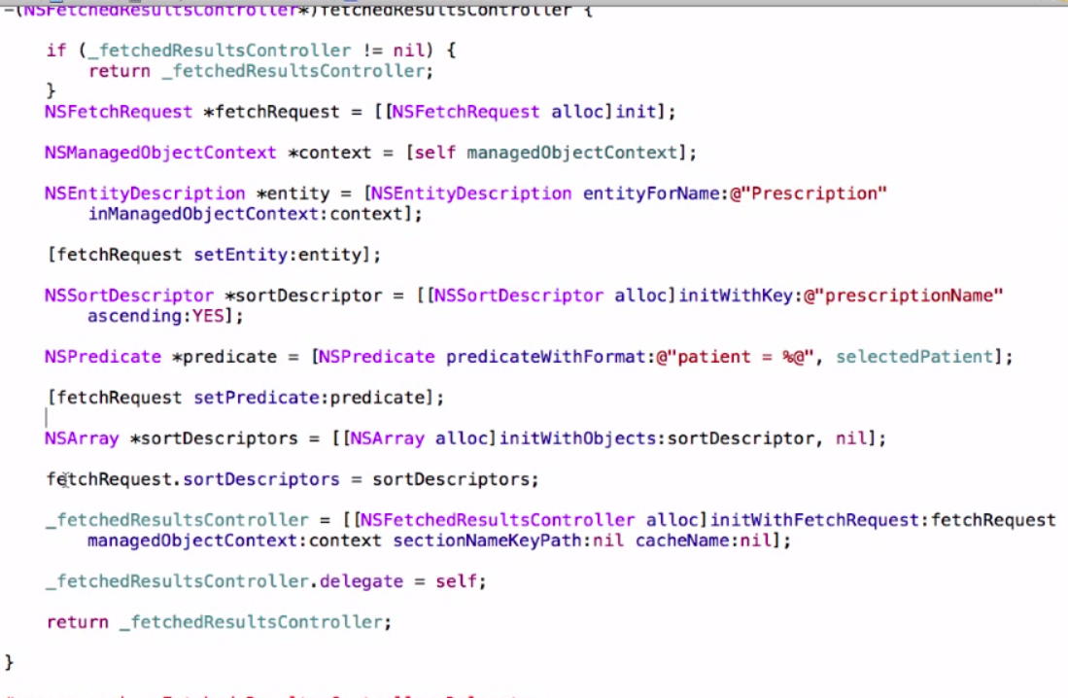
* Now change the FetchedResultsCOntroller delegate copied form the PtientTVC also to reflect Prescription objects instead of Patient
* Now code transition from PrescriptionTableViewController to AddPrescriptionViewController (check the identifier in the Storyboard)
* 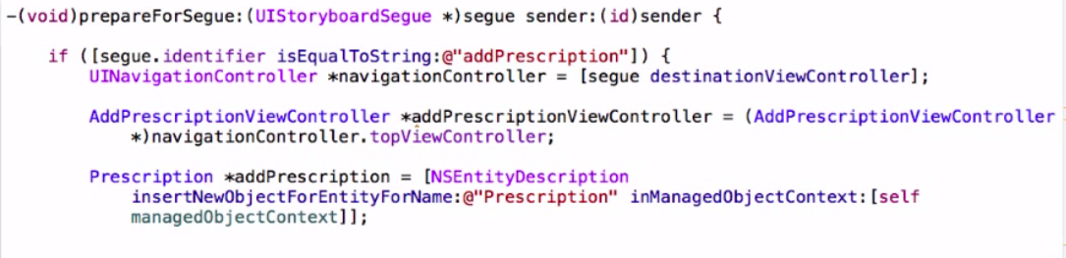
* ** Now we need to pass the addPrescriptionViewController a reference to our selectedPatient.
  + Might think that we need to pass some relationship object like NSSet but Core Data takes care of relationships for us
  + All we really need to do is tell Core Data what patient we are dealing with and it figures out the rest: for instance what Prescriptions belong to this patient.
  + So we only need to do here is refer to our Prescriptions Patient object on our AddPrescriptions View Controller and assign it the selected Patient object we selected with our predicate statement in the FetchedResultsController method
  + Se we need to add several propertied in AddPatientsVC to add properties we will be referencing
* 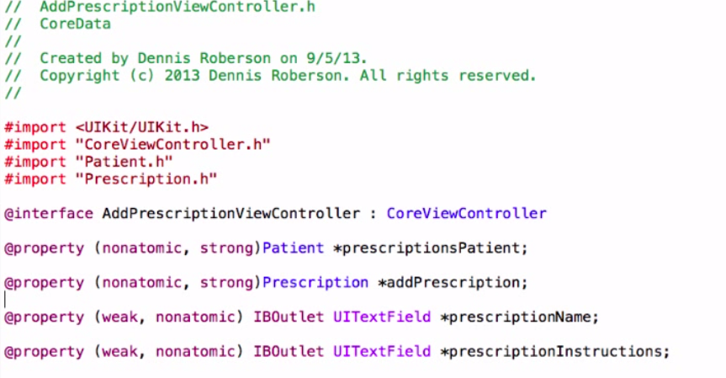
  + prescriptionsPatient is the object for the Patient that has the Prescription we are going to add
  + addPresription is the new Prescription we are going to add;
  + Notice properties are “strong”
* Back to the transition method in the segue:
  + Assign the selected Patient object to the prescriptionsPatient property
  + Also assign the addPrescription object to the view controller’s addPrescription property (see added two lines below)
* 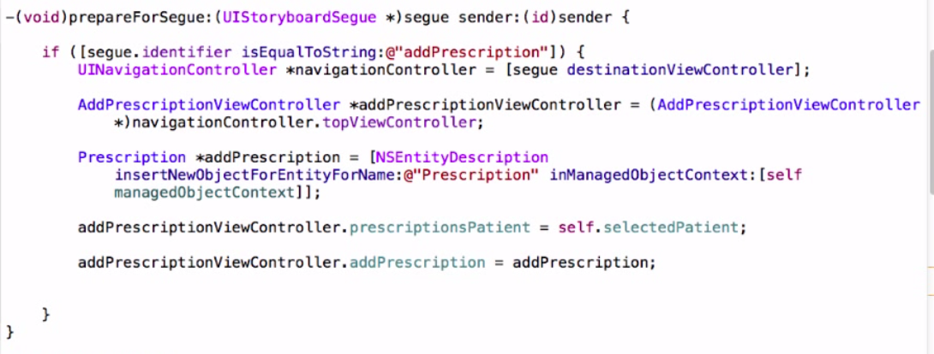
* So Core Data manages these relationships and you don’t need to do this!
* Now copy and edit Core Data Table View Data Source (as before)
* 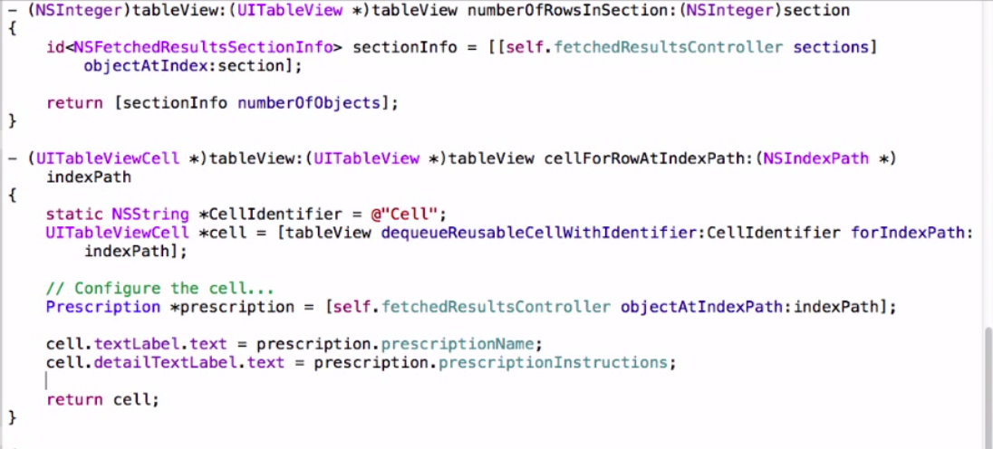
* Save method in the AddPrescriptionViewController:
  + synthesize the properties
    - addPrescription (the prescription we want to add)
    - prescriptionsPatient (the Patient who has the Prescription)
  + and edit the save method:
* 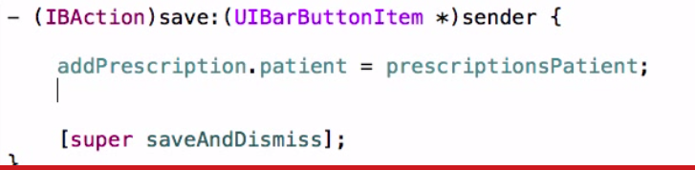
* This sets the relationship in the new Prescription to the Patient which was selected (i.e. prescriptionsPatient)
* Next add the values entered in the text fields to the object:
* 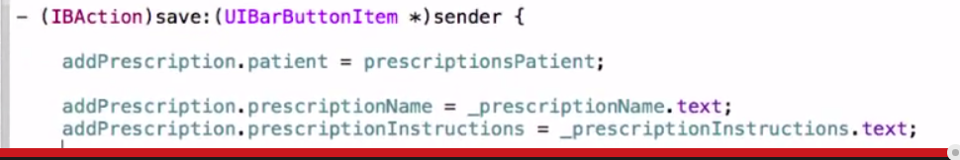
* Back to PrescriptionsTVC to code the performFetch method against the FetchedResultsController
* viewDidLoad
* 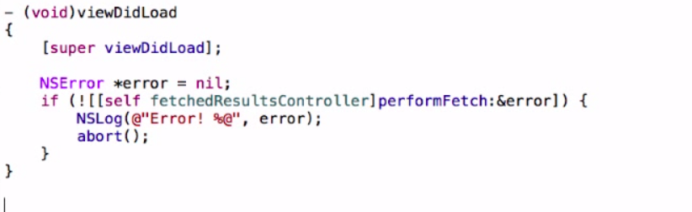
* viewWillAppear (to assure the Table is always updated)
* 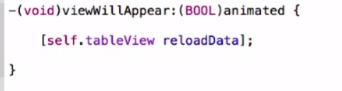
* Delete:
* PrescriptionsTVC: (copy from PatientsTVC)
* Hints:
* Check imports first
* NSManaged Object and Contrllers
* Use NSLog to verify passes between controllers (especially in viewdDidLoad and viewWillDisappear)
* If change the data model either
  + regenerate NSManaged Class Files
  + or manually make the changes.
  + also: reset the simulator
* Dennis Roberson
* <http://www.youtube.com/watch?v=KzsPntlhLxM>
* Setup:
  + Created two VCs with IBOutlets, IBActions and properties for input and passing data between
  + Two labels for information to be sent back to us (cant see them in the green background)
  + A text box for input sent to the second VC
* 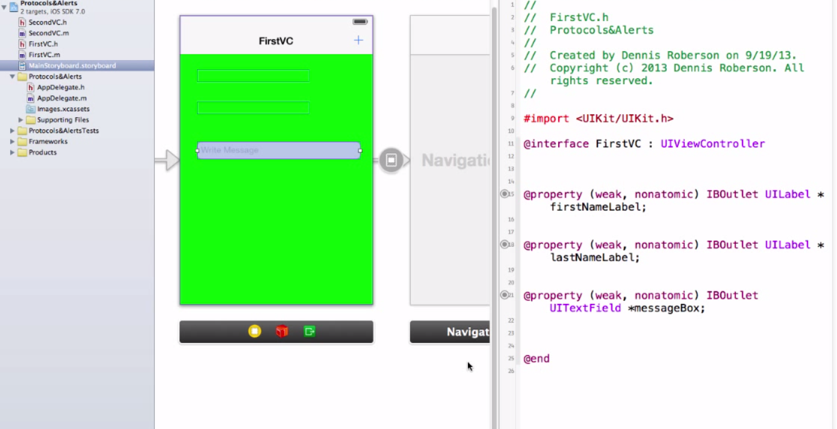
* 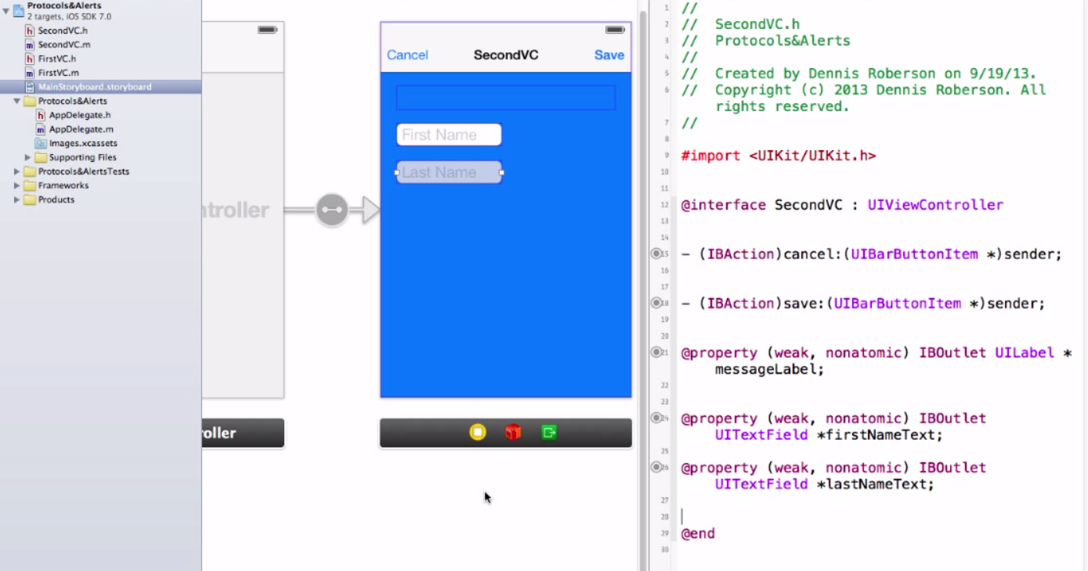
* Start coding in second VC header file:
  + Define the protocol that we will be passing two variables back to first VC
  + so we define the protocol passNames and the two methods
  + also define the delegate property for the protocol <passNames>
  + and the properties to hold the firstName and lastName strings in
  + and also one for the message that will be passed to us from VC1:
* 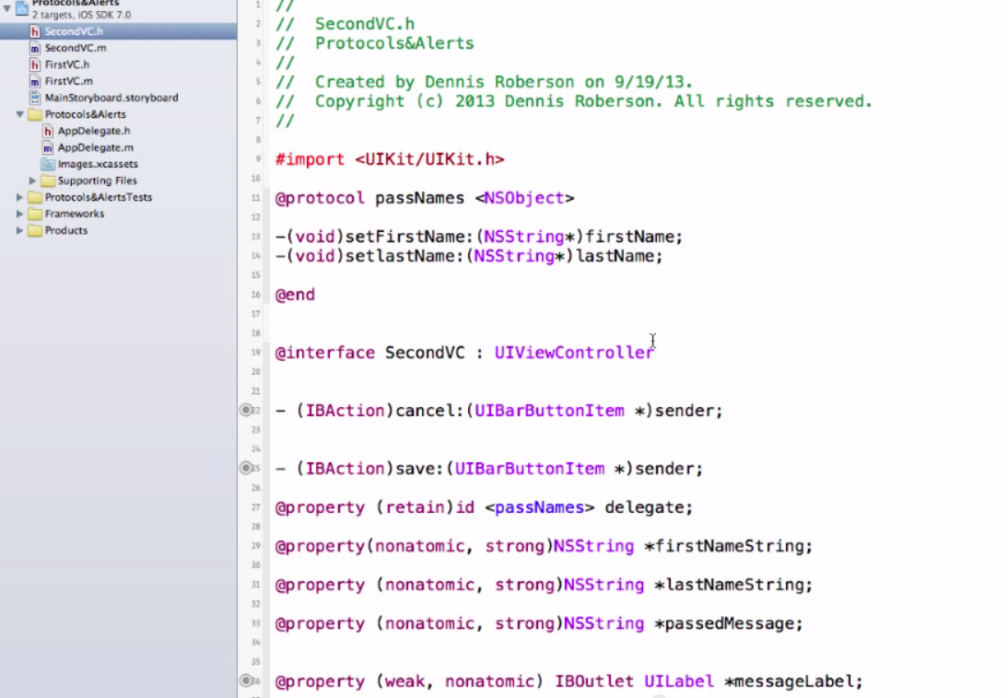
* In SeconVC.m implementation file:
  + Import first VC (header file)
  + synthesize the properties we need
  + edit viewDidLoad to display message displayed from the VC1
* 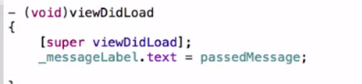
* also the cancel and save methods
* 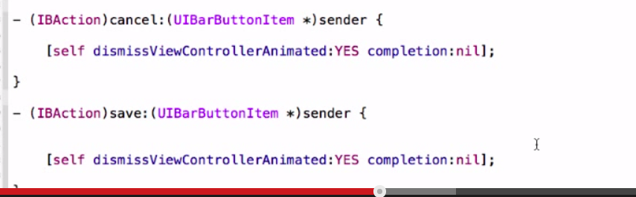
* In the save method we add the code to pass all the data back to the first view controller, often may add it to other methods. For example if the transition between the first VC and second VC was a push we would be using the back button to dismiss our second VC and could add it to the viewWillDisappear method.
  + assign the text input(s) to the property(ies)
  + call the delegate method setFirstName with the parameter:firstNameString, similarly for lastName
* 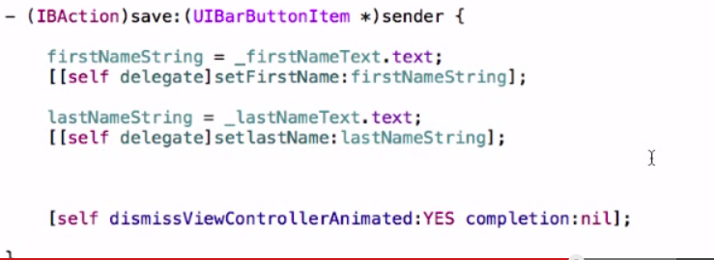

Now do the same thing for the First VC

* + import SecondVC.h
  + tell the class that we are going to conform to the passNames protocol (add the <passNames> protocol to the interface declaration)

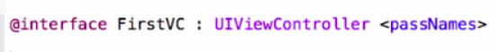

* + add properties created in VC2 and passed back to VC1
  + So here is what the file looks like:
* 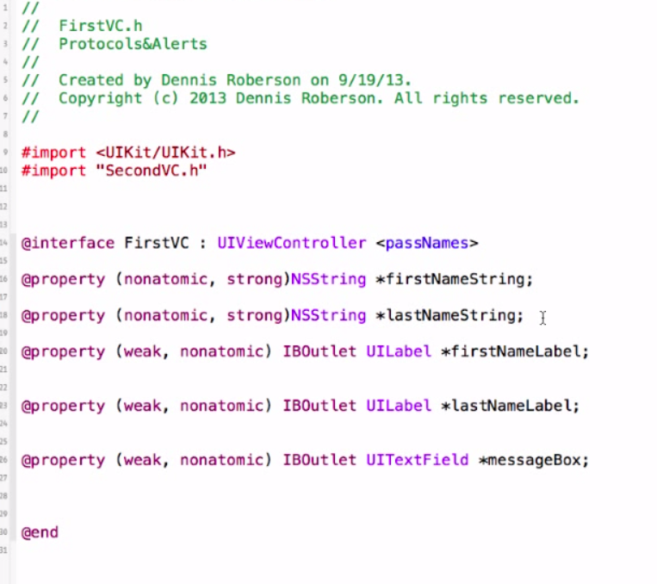
* Now in FirstVC.m:
  + Synthesize the properties we are going to pass: firstNameString and lastNameString
  + add prepareForSegue to pass the information we want to pass to the second view controller
  + define the destination view controller
  + and identify the second VC as the top view controller in the navigation stack
  + assign the entered text (_messageBox.text to passedMessage property of the SecondVC
  + Set the delegate to ourself
* 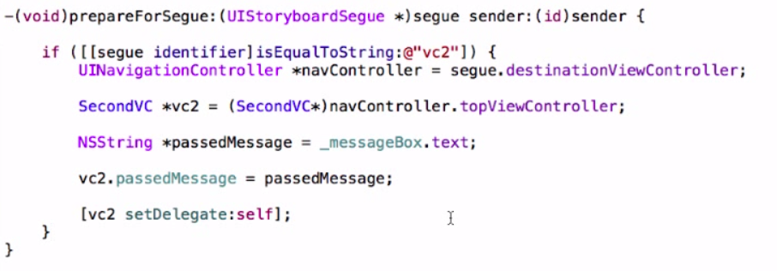
* Now ready to code our protocol methods
  + add a pragma mark
  + write the methods
  + In FirstVC.m:
* 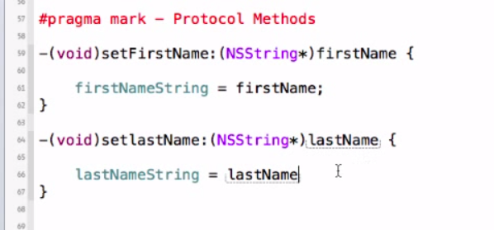
  + Note: this assigns the value of the argument passed in setFirstName to the property firstNameString in this VC (FirstVC)
* Now we can utilize these in viewWillAppear to fill in the Labels with the strings passed back by the SecondVC
* 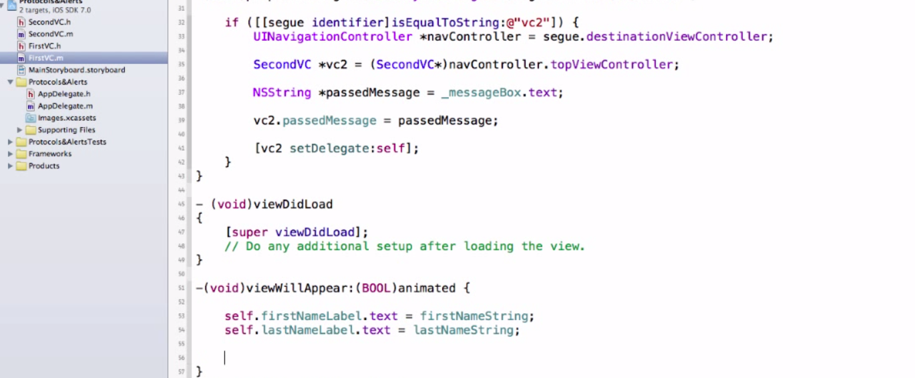
* Alerts: check for First name as required field
* 